SUBCOURSE EDITION
IT 0646 A

US ARMY INTELLIGENCE CENTER AND SCHOOL

PLOT VERTICAL AERIAL PHOTOS

AND

MASTER COVER TRACE

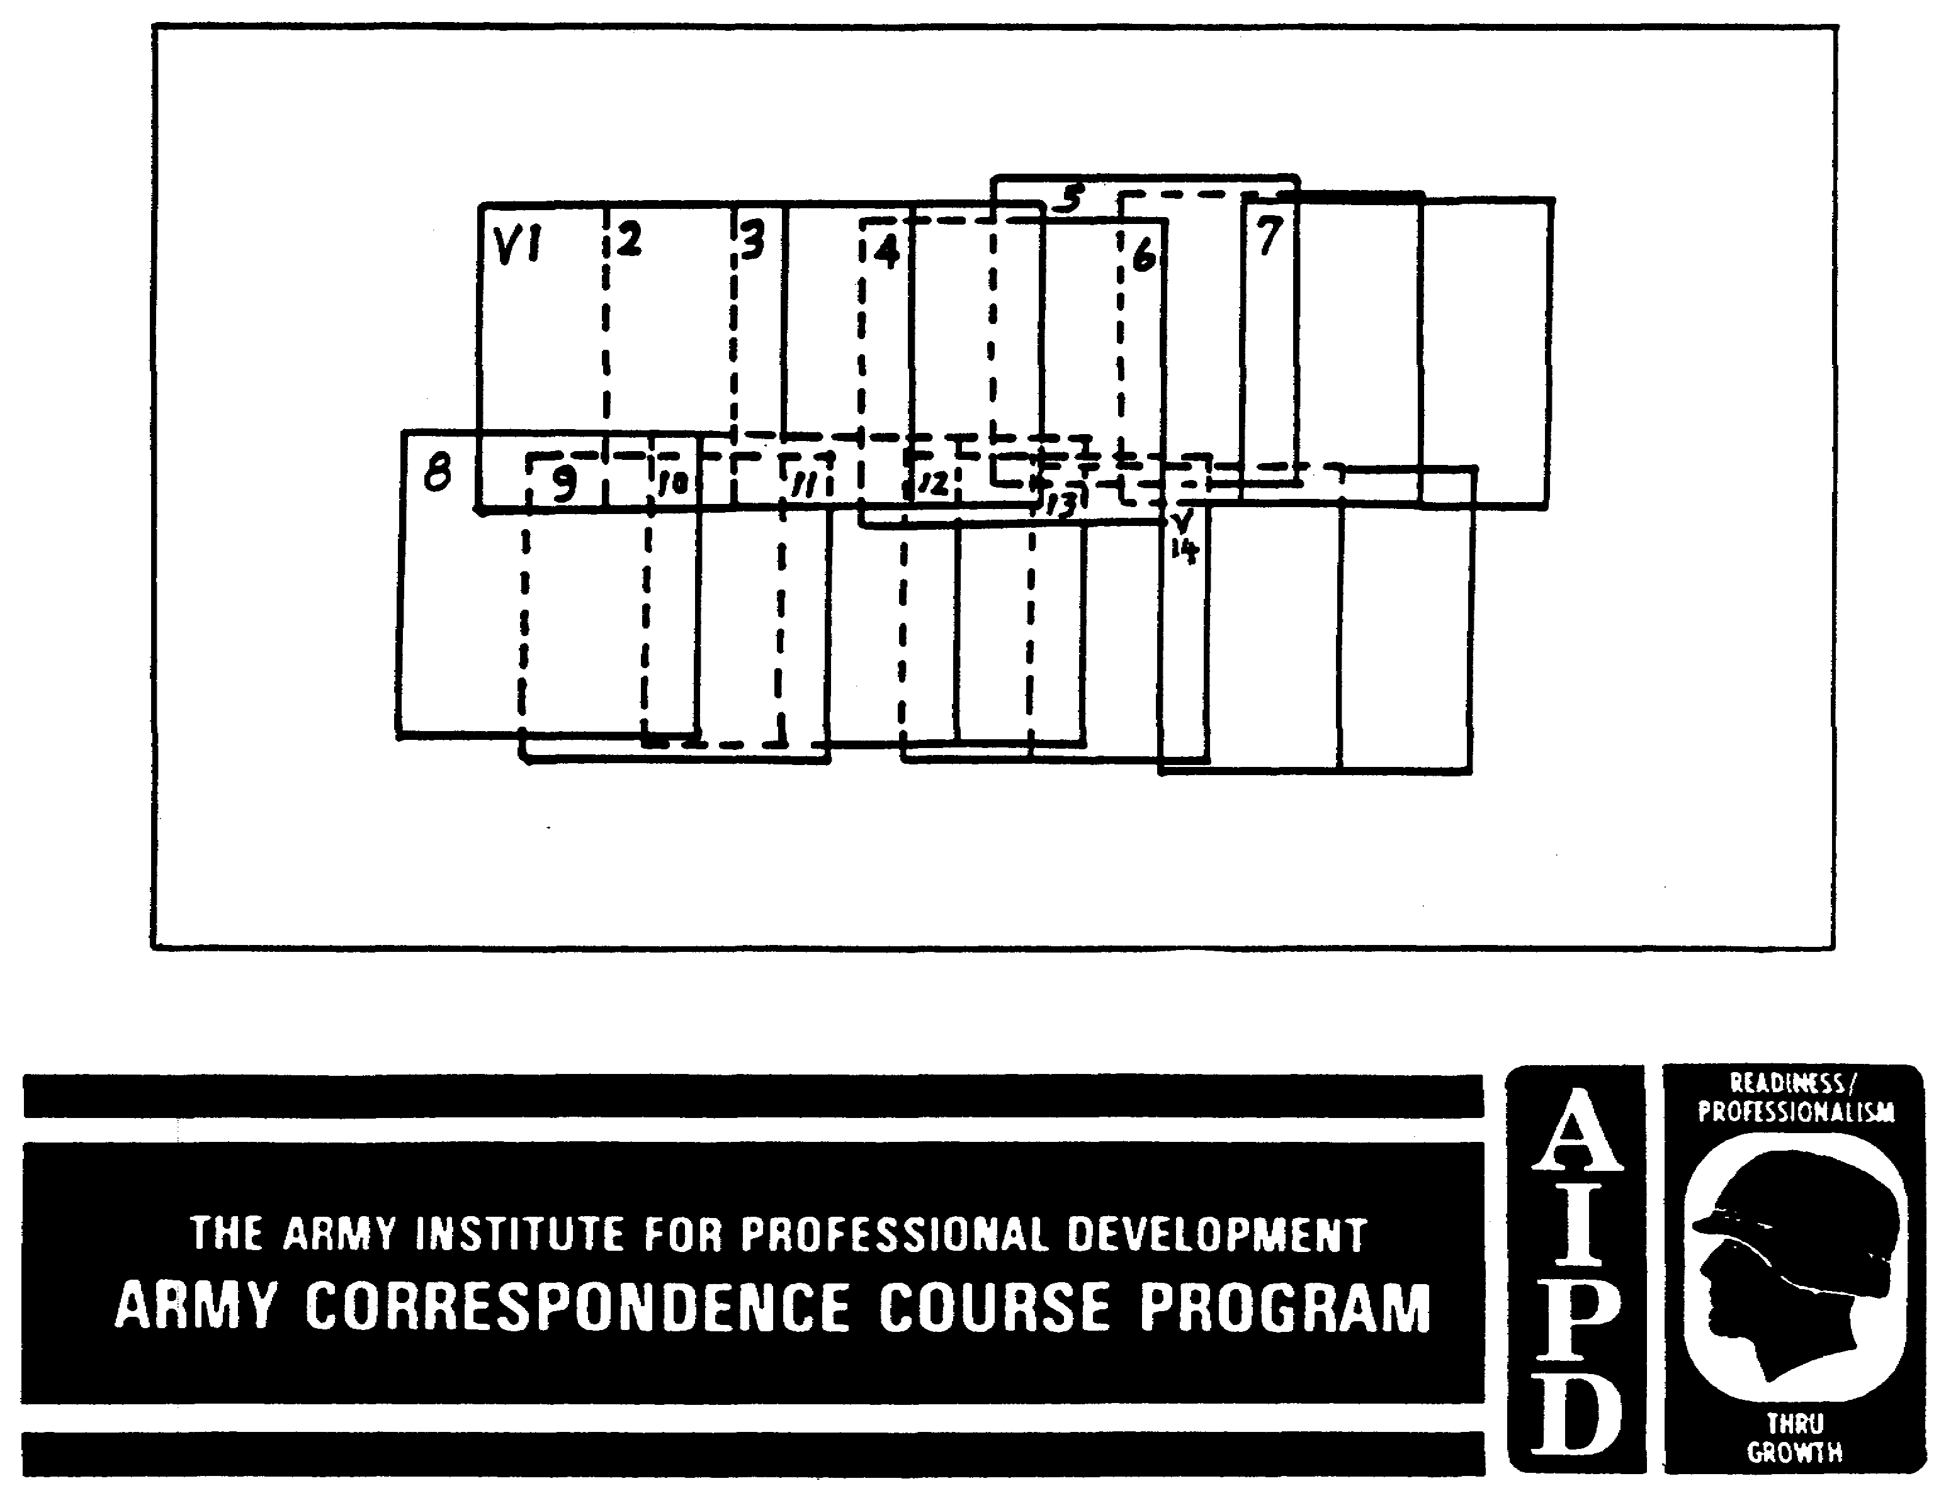

PLOT VERTICAL AERIAL PHOTOS AND MASTER COVER TRACE

Subcourse Number IT 0646

EDITION A

US Army Intelligence Center and School
Fort Huachuca, AZ 85613-7000

3 Credit Hours

Edition Date: December 1991

SUBCOURSE OVERVIEW

This subcourse is designed to teach you basic procedures involved with plotting vertical aerial photos and master cover trace. Contained within this subcourse are instructions on how to plot vertical aerial photos and a master cover trace.

There are no prerequisites for this subcourse.

This subcourse reflects the doctrine which was current at the time the subcourse was written.

TERMINAL LEARNING OBJECTIVE

TASKS: You will use basic procedures in plotting vertical aerial photos and the master cover trace.

CONDITIONS: You will have access to extracts from FM 21-26, STP 34-96D1-SM, and TC 34-55.

STANDARDS: You will plot vertical aerial photos and the master cover trace in accordance with FM 21-26, STP 34-96D1-SM, and TC 34-55.

i IT 0646

TABLE OF CONTENTS

Section Page

Subcourse Overview

LESSON ONE: AERIAL PHOTO PLOTTING 1

Part A: Overlay Preparation 2
Part B: Pilot's Trace 3
Part C: Plotting Frame, Overlap, and Sidelap 6
Part D: Field Plot 8
Part E: Interpretation Plot 12
Part F: Plotting Problems 16
Practice Exercise 18
Answer Key and Feedback 20

LESSON TWO: VERTICAL AERIAL PHOTO PLOTTING 21

Part A: Inspection Method 22
Part B: Plotting Template Method 26
Part C: Point Inspection Method 31
Part D: Proportional Divider Method 33
Practice Exercise 40
Answer Key and Feedback 42

LESSON THREE: MASTER COVER TRACE PLOTTING 44

Part A: Master Cover Trace 45
Part B: Preparing and Maintaining Master
Cover Trace 48
Practice Exercise 51
Answer Key and Feedback 52

IT 0646 ii

LESSON ONE

AERIAL PHOTO PLOTTING

MOS: Manual Tasks: 301-338-1609
301-338-3701

OVERVIEW

TASK DESCRIPTION:

In this lesson you will learn to prepare an overlay, utilize the pilot's trace, and describe a field plot, interpretation plot, and plotting problems.

LEARNING OBJECTIVE:

ACTIONS: Describe the information and procedures required to prepare an overlay, utilize the pilot's trace, and describe a field plot, interpretation plot, and plotting problems.

CONDITIONS: You will be given access to extracts from FM 21-26, STP 34-96DI-SM, and TC 34-55.

STANDARDS: Preparation of an overlay, utilization of a pilot's trace and describing a field plot, interpretation plot, and plotting problems will be in accordance with FM 21-26, STP 34-96D1-SM, and TC 34-55.

REFERENCES: The material contained in this lesson was derived from the following publications:

FM 21-26
STP 34-96D1-SM
TC 34-55.

INTRODUCTION

Plots of aerial photo missions are critical aspects of the intelligence process. They serve to orient the imagery analyst (IA), facilitate control by filing and dissemination, and aid in subsequent imagery analysis.

1 II 0646

PART A: OVERLAY PREPARATION

1. Place and tape overlay paper to map. Knowing the general area of coverage, you should place the overlay paper over the pertinent area of the map(s) and tape it down at the four corners.

2. Register overlay paper to map(s). Form the registration marks by tracing the universal transverse mercator (UTM) grid intersections or geographic (GEO) coordinates at the top right and bottom left of the overlay. These registration marks are large plus (+) signs and correspond to grid lines on the map. There is no definite size for these registration marks.

3. Label registration marks. Label each registration mark with proper coordinates.

a. Mark UTM grid coordinates using the 100,000 meter (m) square identification at the upper right and lower left of the registration mark. Add grid square digits (two digits for 1:50,000 maps and one digit for 1:250,000 maps) as shown in Figure 1-1.

b. Mark GEO coordinates as shown in Figure 1-1.

4. Add appropriate legend and classification. Legends are shown in pertinent figures, i.e., Figure 1-2 (Pilot's Trace), etc. You must add the classification to the top and bottom of the overlay in larger than normal lettering and to the bottom of the legend in normal lettering. Classification should be the same as the one shown on the mission request.

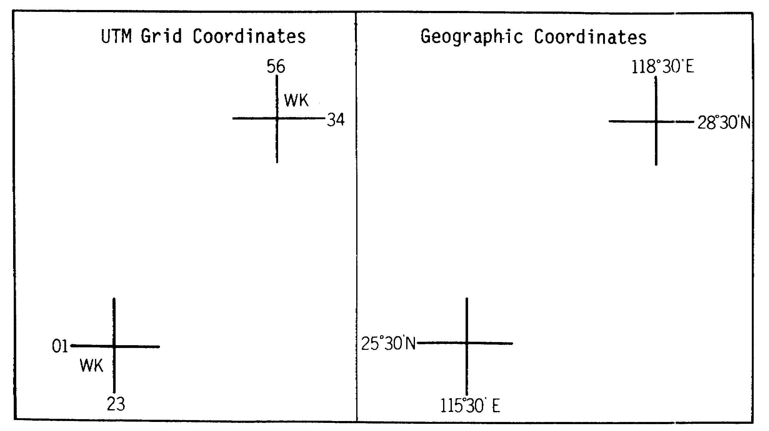

Figure 1-1. Overlay Preparation.

IT 0646 2

PART B: PILOT'S TRACE

1. The pilot's trace (also referred to as the mission coverage trace) is an annotated map or map overlay that shows the ground track of the aircraft during the accomplishment of an aerial reconnaissance and surveillance (R&S) mission.

a. The pilot or air crew prepares this trace by showing:

(1) Registration marks.

(2) Start and end of each flight line.

(3) Number of flight lines.

(4) Sensor data (Legend).

(5) Classification.

b. The pilot's trace is the first plot made of the mission during the pilot's debriefing and accompanies the film from the photographic laboratory to the imagery analysis section.

c. The pilot's trace facilitates the immediate exploitation of the imagery by the IA for more detailed plots, which are discussed further in the lesson.

2. There are two types of pilot's traces: area coverage (Figure 1-2) and route reconnaissance (Figure 1-3), which can be plotted on 1:50,000 or 1:250,000 maps or map overlays.

a. For area coverage an arrow at the end of the flight line indicates flight direction. Numbering of flight lines shows the sequence in which they were flown.

b. For route reconnaissance the exact route followed is shown; times at start, major turns, and end are indicated.

c. The legend must include:

(1) Mission number

(2) Flying organization

(3) Date and time on target (TOT)

(4) Altitude flown

(5) Camera used

(6) Map data

(7) Weather in the target area.

3 IT 0646

REMEMBER: You must show the CLASSIFICATION AT TOP AND BOTTOM 1N LARGER THAN NORMAL LETTERING AND AT THE BOTTOM OF THE LEGEND in normal lettering.

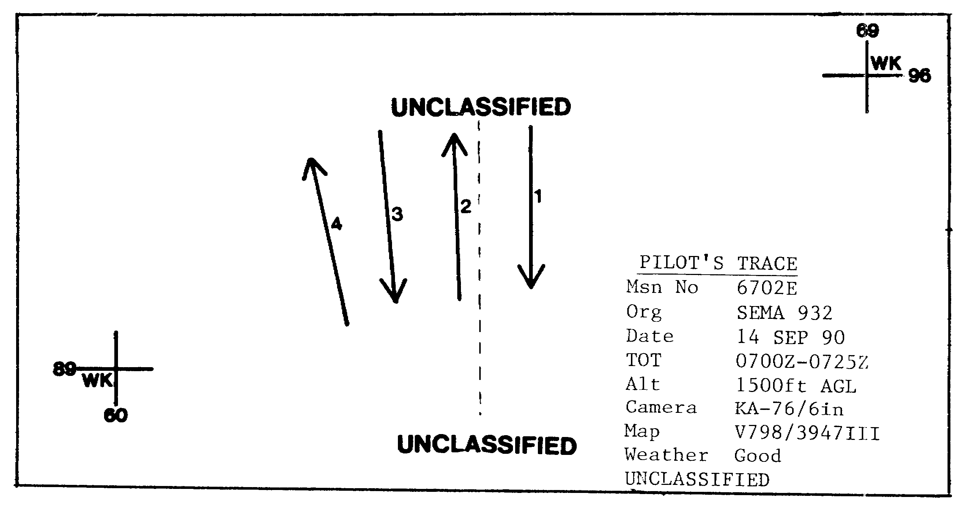

Figure 1-2. Pilot's Trace for Area Coverage Mission.

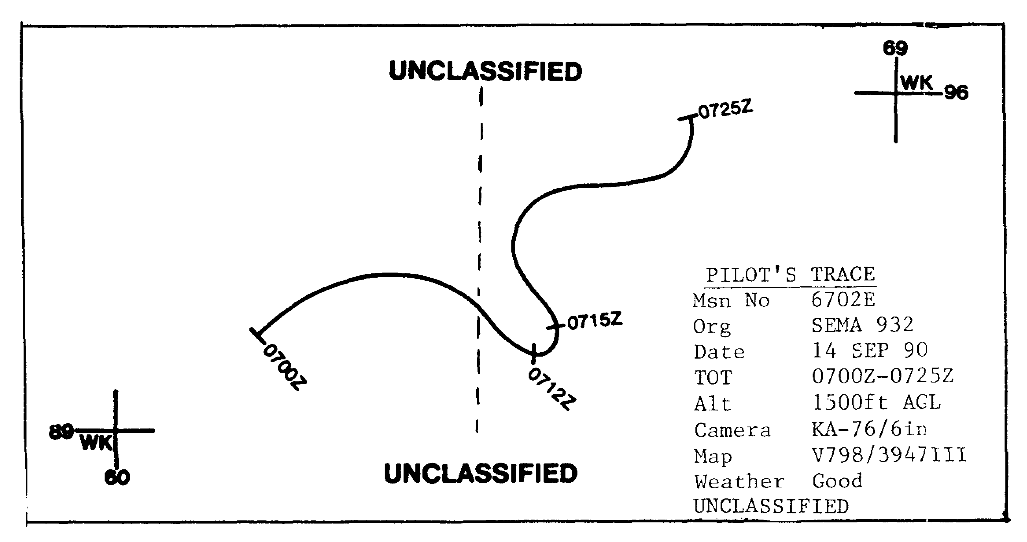

Figure 1-3. Pilot's Trace for Route Reconnaissance Mission.

IT 0646 4

3. A typical pilot's trace keyed to a 1:250,000 map is shown in Figure 1-4. In this case you may nave to transfer the pilot's trace to a 1:50,000 map for more detailed plotting.

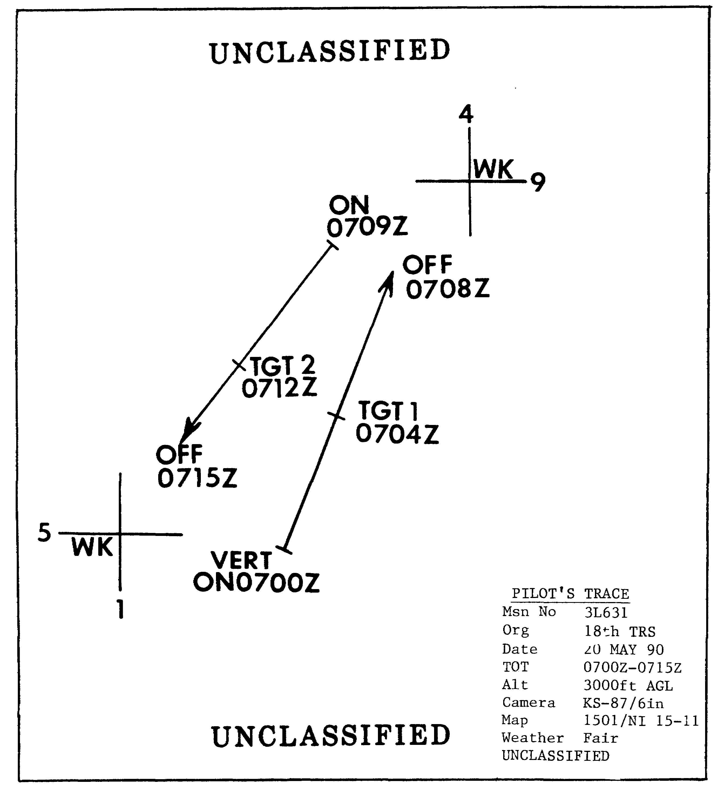

Figure 1-4. Pilot's Trace Keyed to 1:250,000 Map.

5 IT 0646

PART C; PLOTTING FRAME, OVERLAP, AND SIDELAP

1. The plotting frame has tour sides. The leading edge is that side of the photo toward the flight direction. The opposite side is the trailing edge. Looking at Figure 1-5, you can determine the flight direction is from right to left. Finally, looking along the flight direction, you can determine a right and left side of the frame to be plotted.

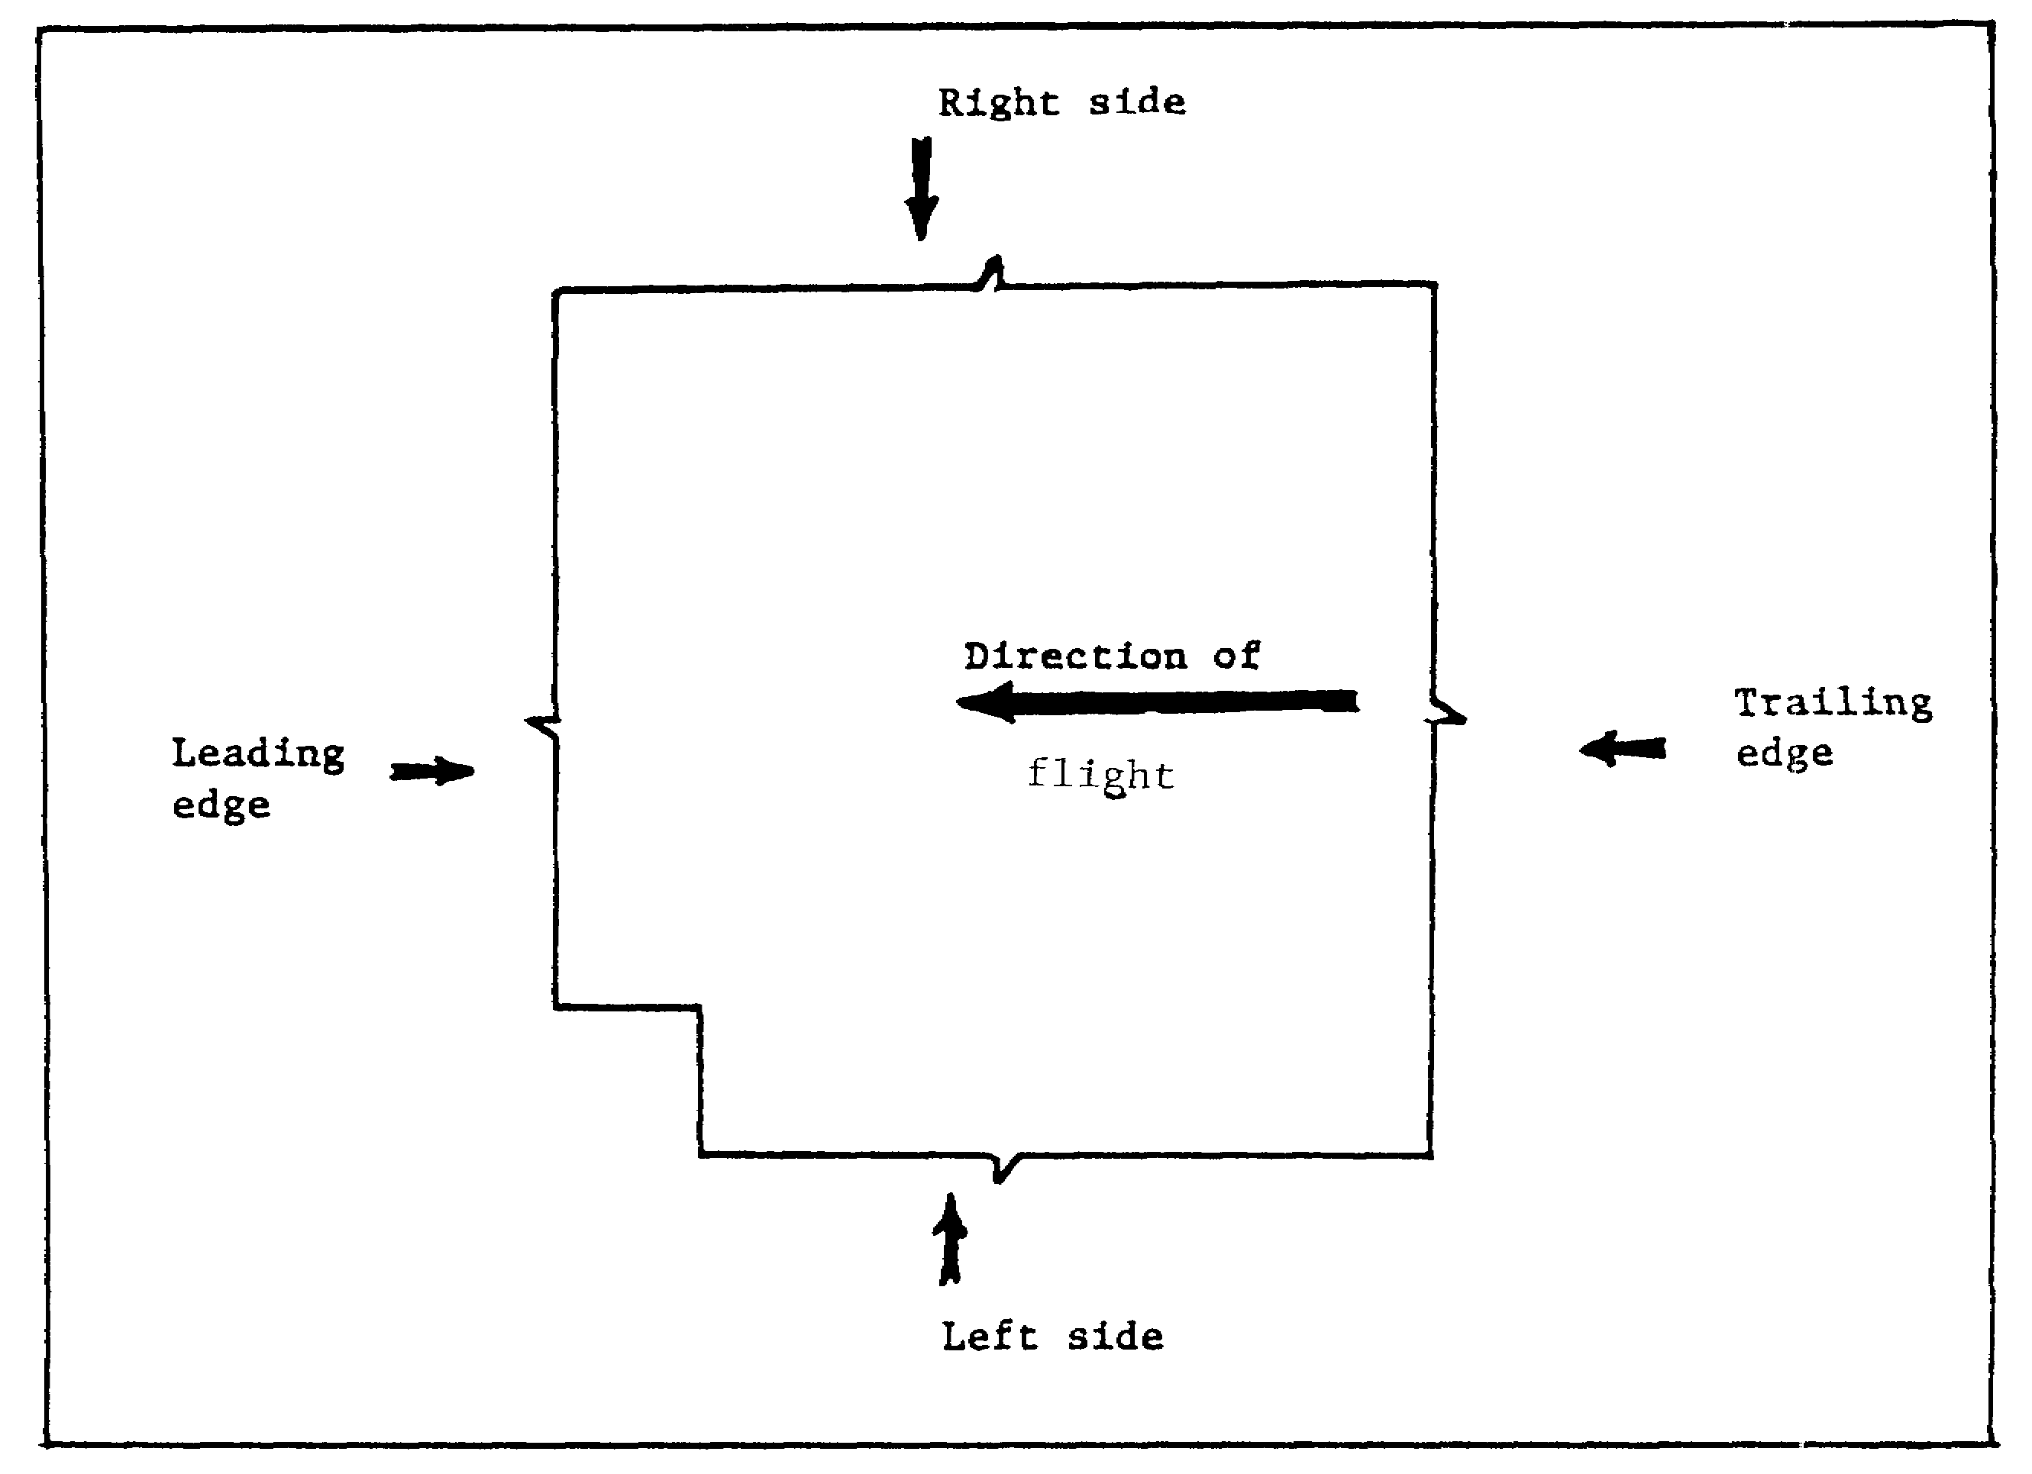

Figure 1-5. Plotting Frame.

IT 0646 6

2. Overlap occurs when a part of one photograph shows the same terrain that appears on a portion of another photograph. The overlap between successive aerial photographs in a flight line is called forward overlap. Inspect Figure 1-6 where you find the hachured area of photograph "2" covering a portion of photograph "VI." Remember 'V" stands for vertical photo and is placed before number 1.

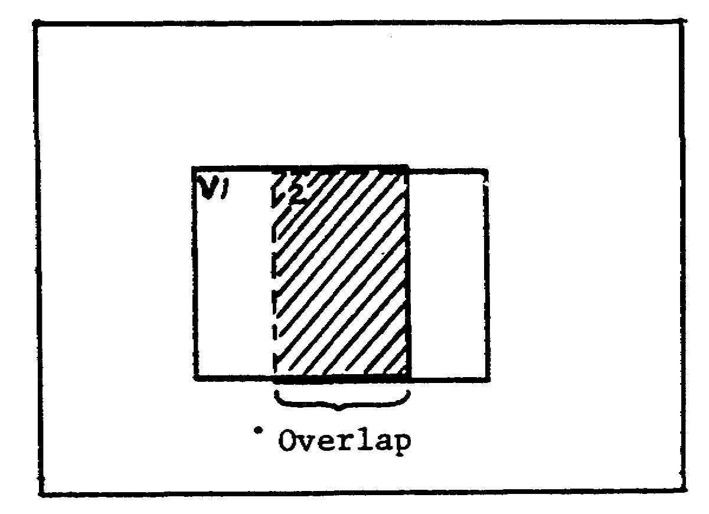

Figure 1-6. Overlap.

3. Sidelap. The overlap between photos on adjacent parallel flight lines is called sidelap. In Figure 1-7, the hachure marks show the area of photos "V1" and "2" covered by photos "8" and "9." Since these photos are in an adjacent flight line, they lap over to the side, thus showing sidelap.

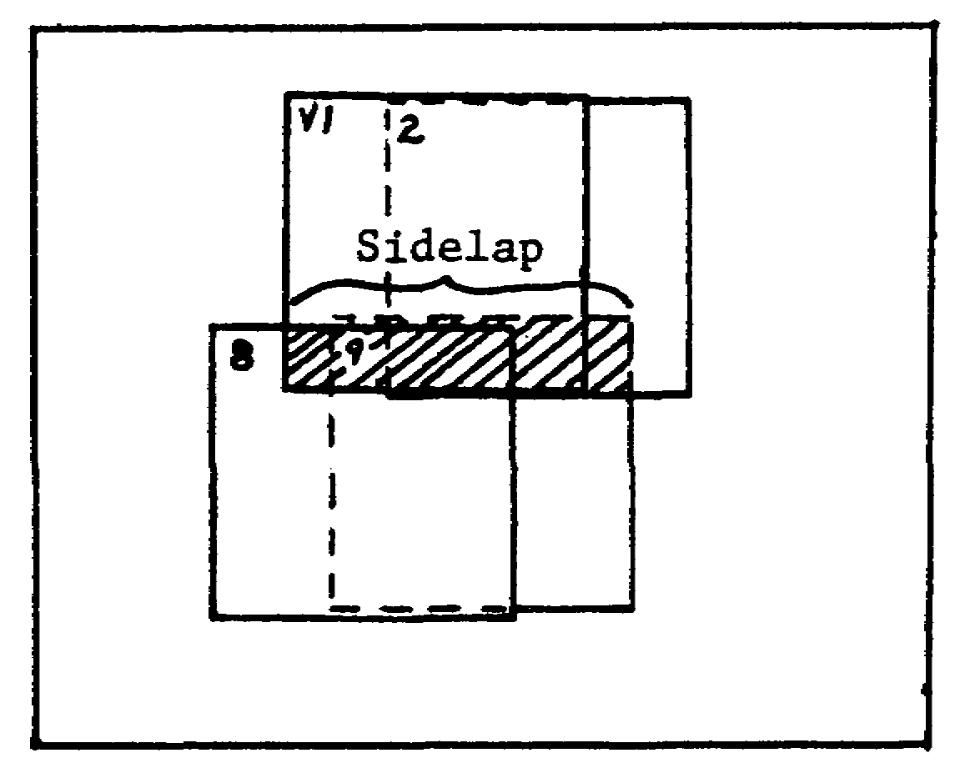

Figure 1-7. Sidelap.

7 IT 0646

PART D: FIELD PLOT

1. The field plot is generally the first plot prepared by an IA; usually on a 1:250,000 scale map. It shows the position and coverage of enough photos to establish the characteristics of the flight line, area coverage, and identify individual photos. There is no set number of photos plotted. Start and end of all flight lines, and turn of flight lines must be plotted as a minimum. You must indicate the first and last photos of the mission by their sensor positions (Table 1-1); furthermore, you should sequentially number the first and last photos in each flight line (Figure 1-8).

Table 1-1. Sensor Designations.

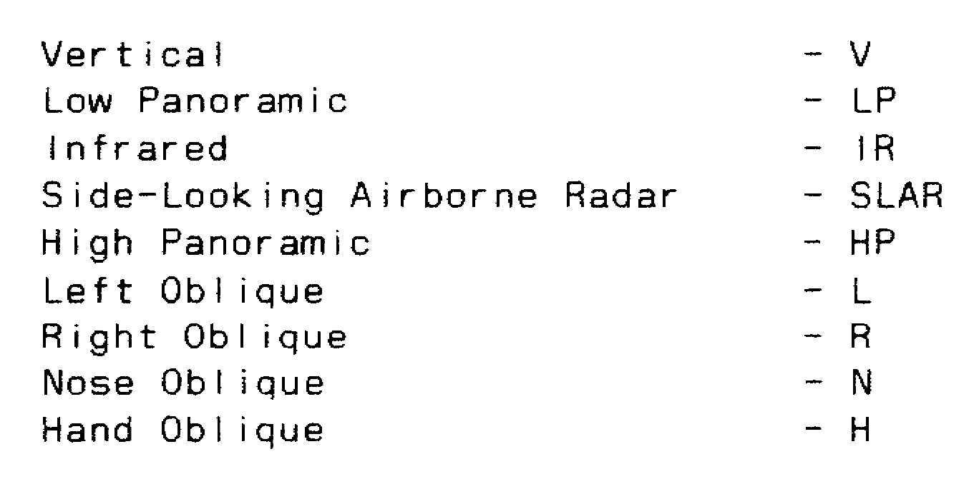

2. In accordance with DIAM 55-5, the following plotting procedures should be used:

a. The field plot must be registered to a 1:250,000 map or map overlay (Figure 1-8). When geographic coordinates are used to register the overlay, you must first tickmark the corners of the map; second, construct a centerline registration, and then place geographic coordinates on the bottom left corner of the map to the left and bottom of the tick mark.

b. Furthermore, use a 12-part legend in three columns and place it at the top of the overlay. The following items pertain to the legend:

(1) Organization

(2) Focal length

(3) Altitude

(4) Map reference, to include scale, series, and map sheet number

(5) Date

(6) TOT using ZULU (Z) time (universal time coordinated (UTC))

(7) Snow cover, if any

IT 0646 8

(8) Cloud cover (indicate percentage of cloud cover)

(9) Additional security information (downgrading, limited access)

(10) Prepared by (rank, name, unit, date)

(11) National imagery interpretation scale (NIIRS) rating

(12) Classification.

NOTE: Add the security classification in larger than any other lettering at the top and bottom center of the overlay.

9 IT 0646

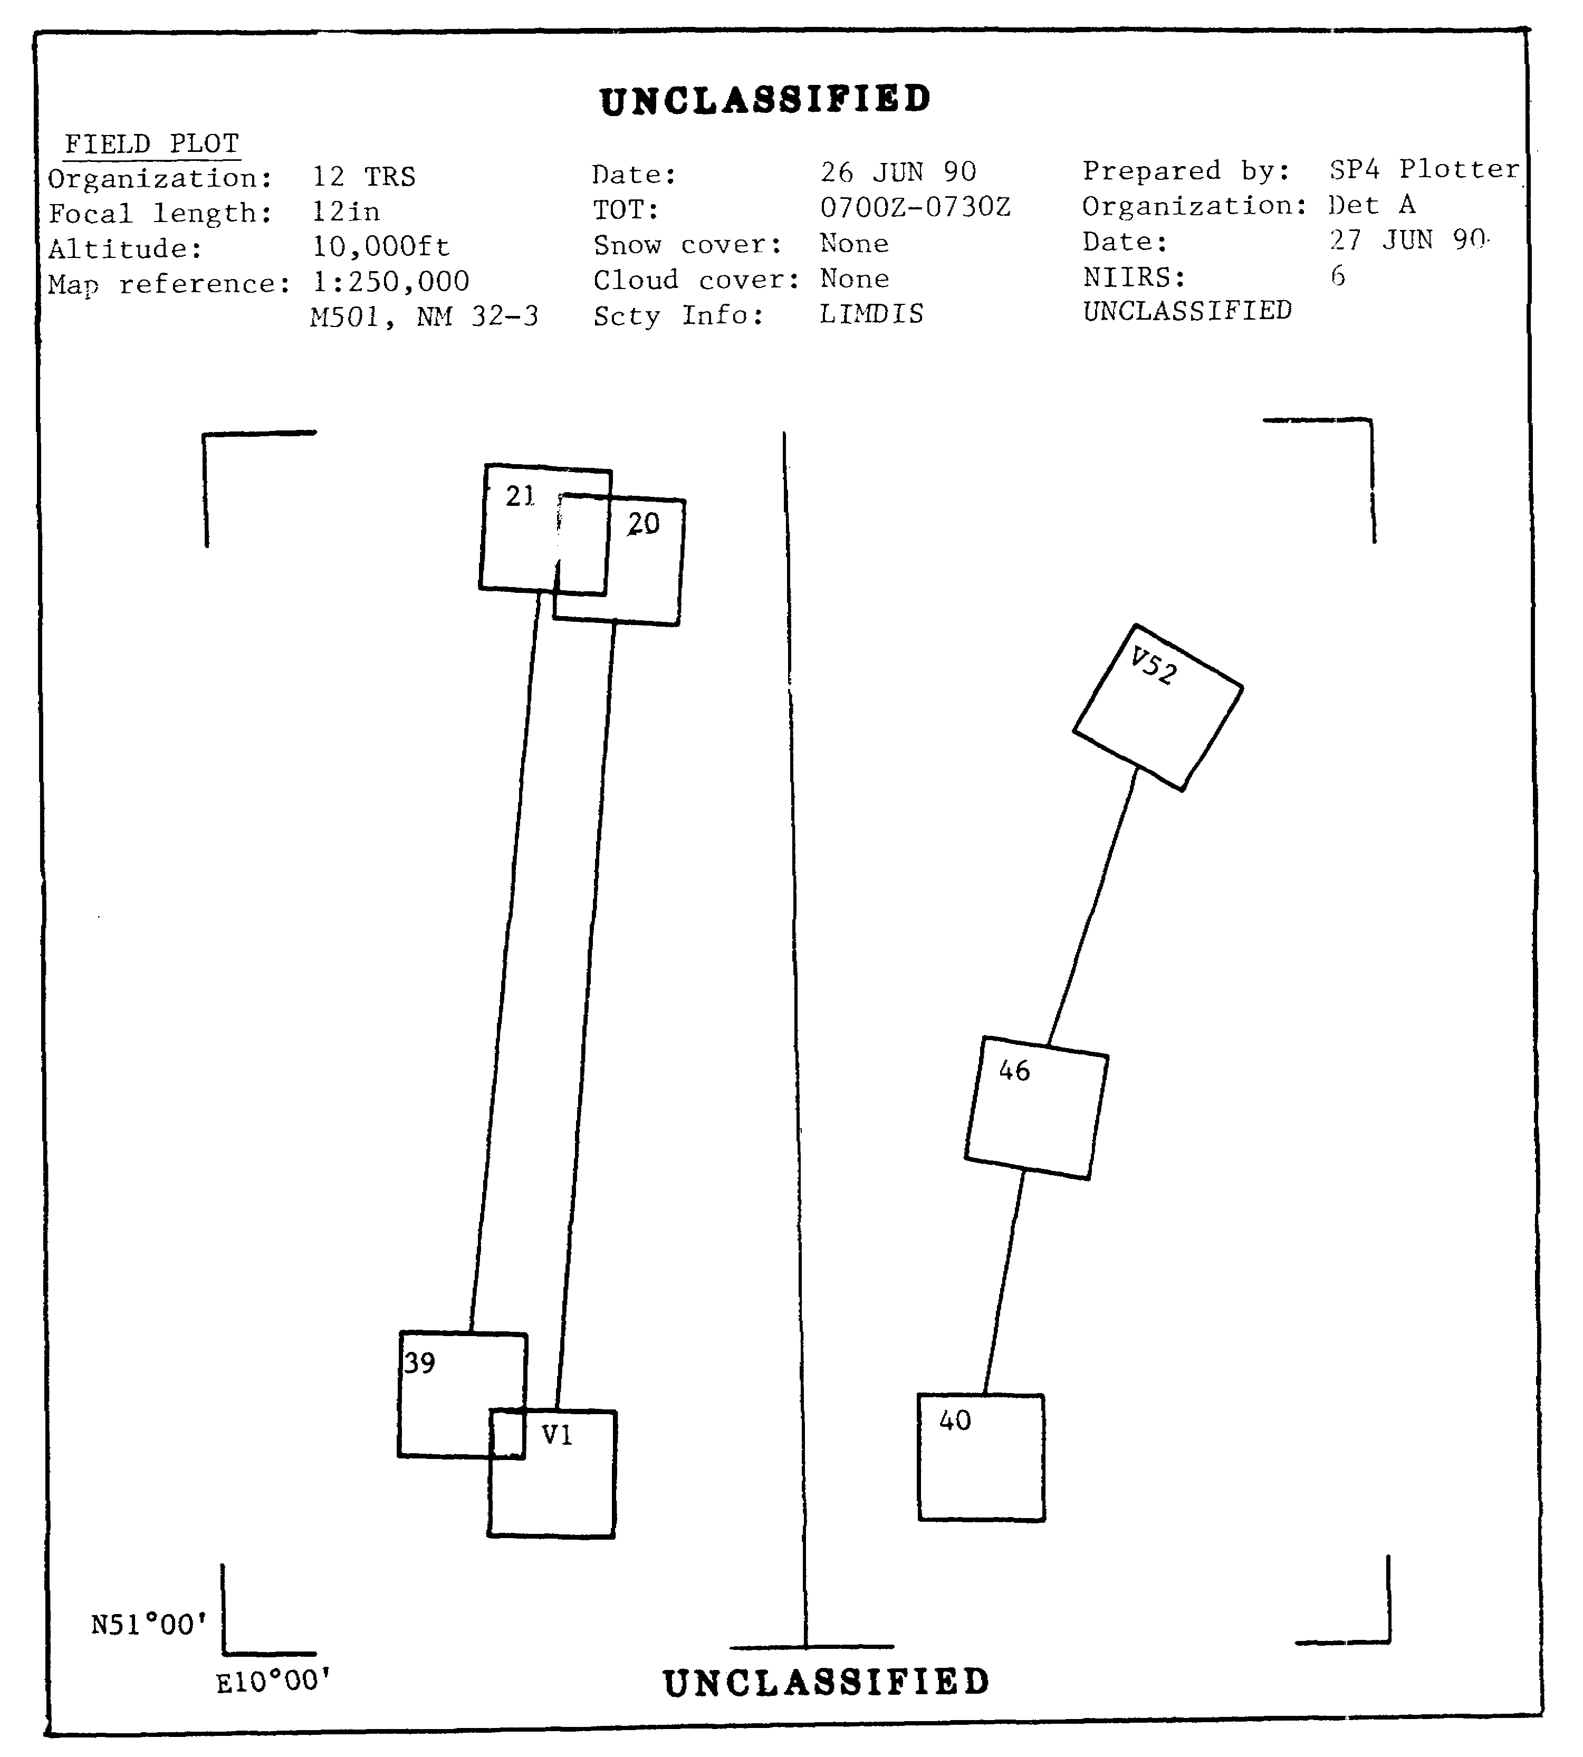

Figure 1-8. Field Plot Using Geographic Coordinates.

IT 0646 10

3. When Universal Transverse Mercator (UTM) coordinates are used, the overlay is registered on a 1:250,000 or 1:50,000 map at the top right and bottom left, by transferring the tick marks; the classification must be shown at the top and bottom center and below the legend. The legend must show map reference, area, photo data and preparer's data (Figure 1-9).

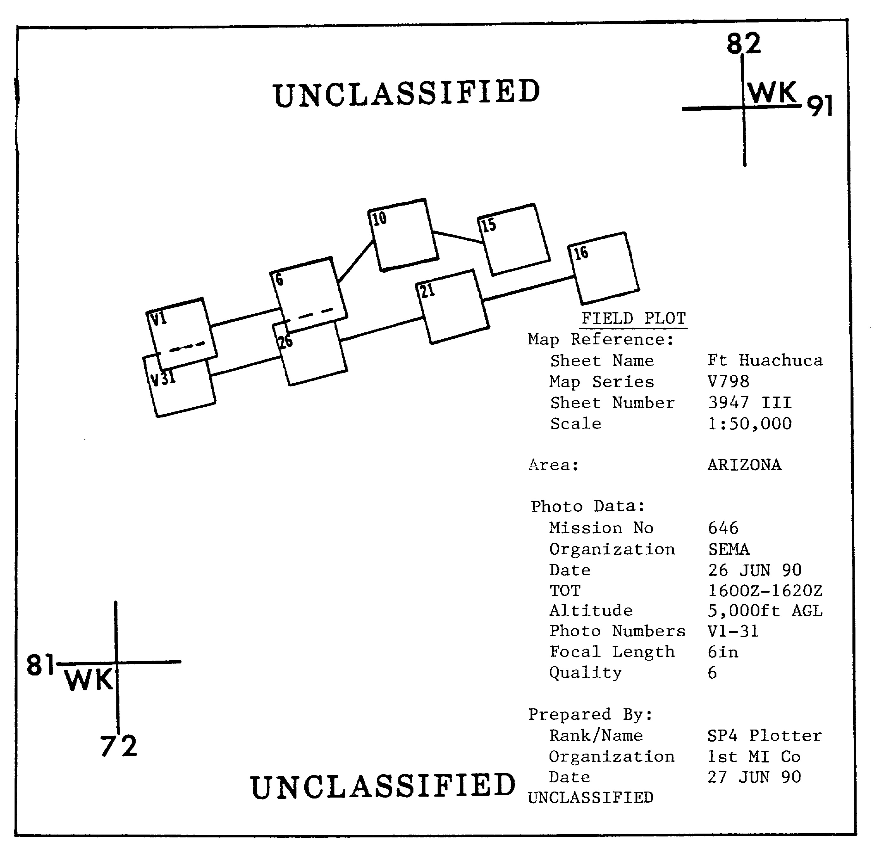

Figure 1-9. Field Plot Using UTM Coordinates.

11 IT 0646

PART E: INTERPRETATION PLOT

1. The second type of plot used by IAs is the interpretation plot. It is used to establish the precise location of targets on which the IA is reporting, confirm photo coverage, and fulfill mission requirements. It is the most accurate means for plotting imagery on a map overlay. It is plotted on a 1:50,000 map by using one of three different methods:

a. Flight line

b. Strip

c. Individual photo.

2. For all three methods, the overlay must be registered, a legend added, and the classification shown at the top and bottom center and below the legend.

a. The flight line method is the least accurate method. It is used only when time is extremely limited. It is prepared by locating the center line of the first, last, and turn frames, then connecting them with straight lines. Frame numbers indicate approximate frame location. The length of coverage only is shown, not the full area of coverage and no overlap or sidelap (Figure 1-10).

IT 0646 12

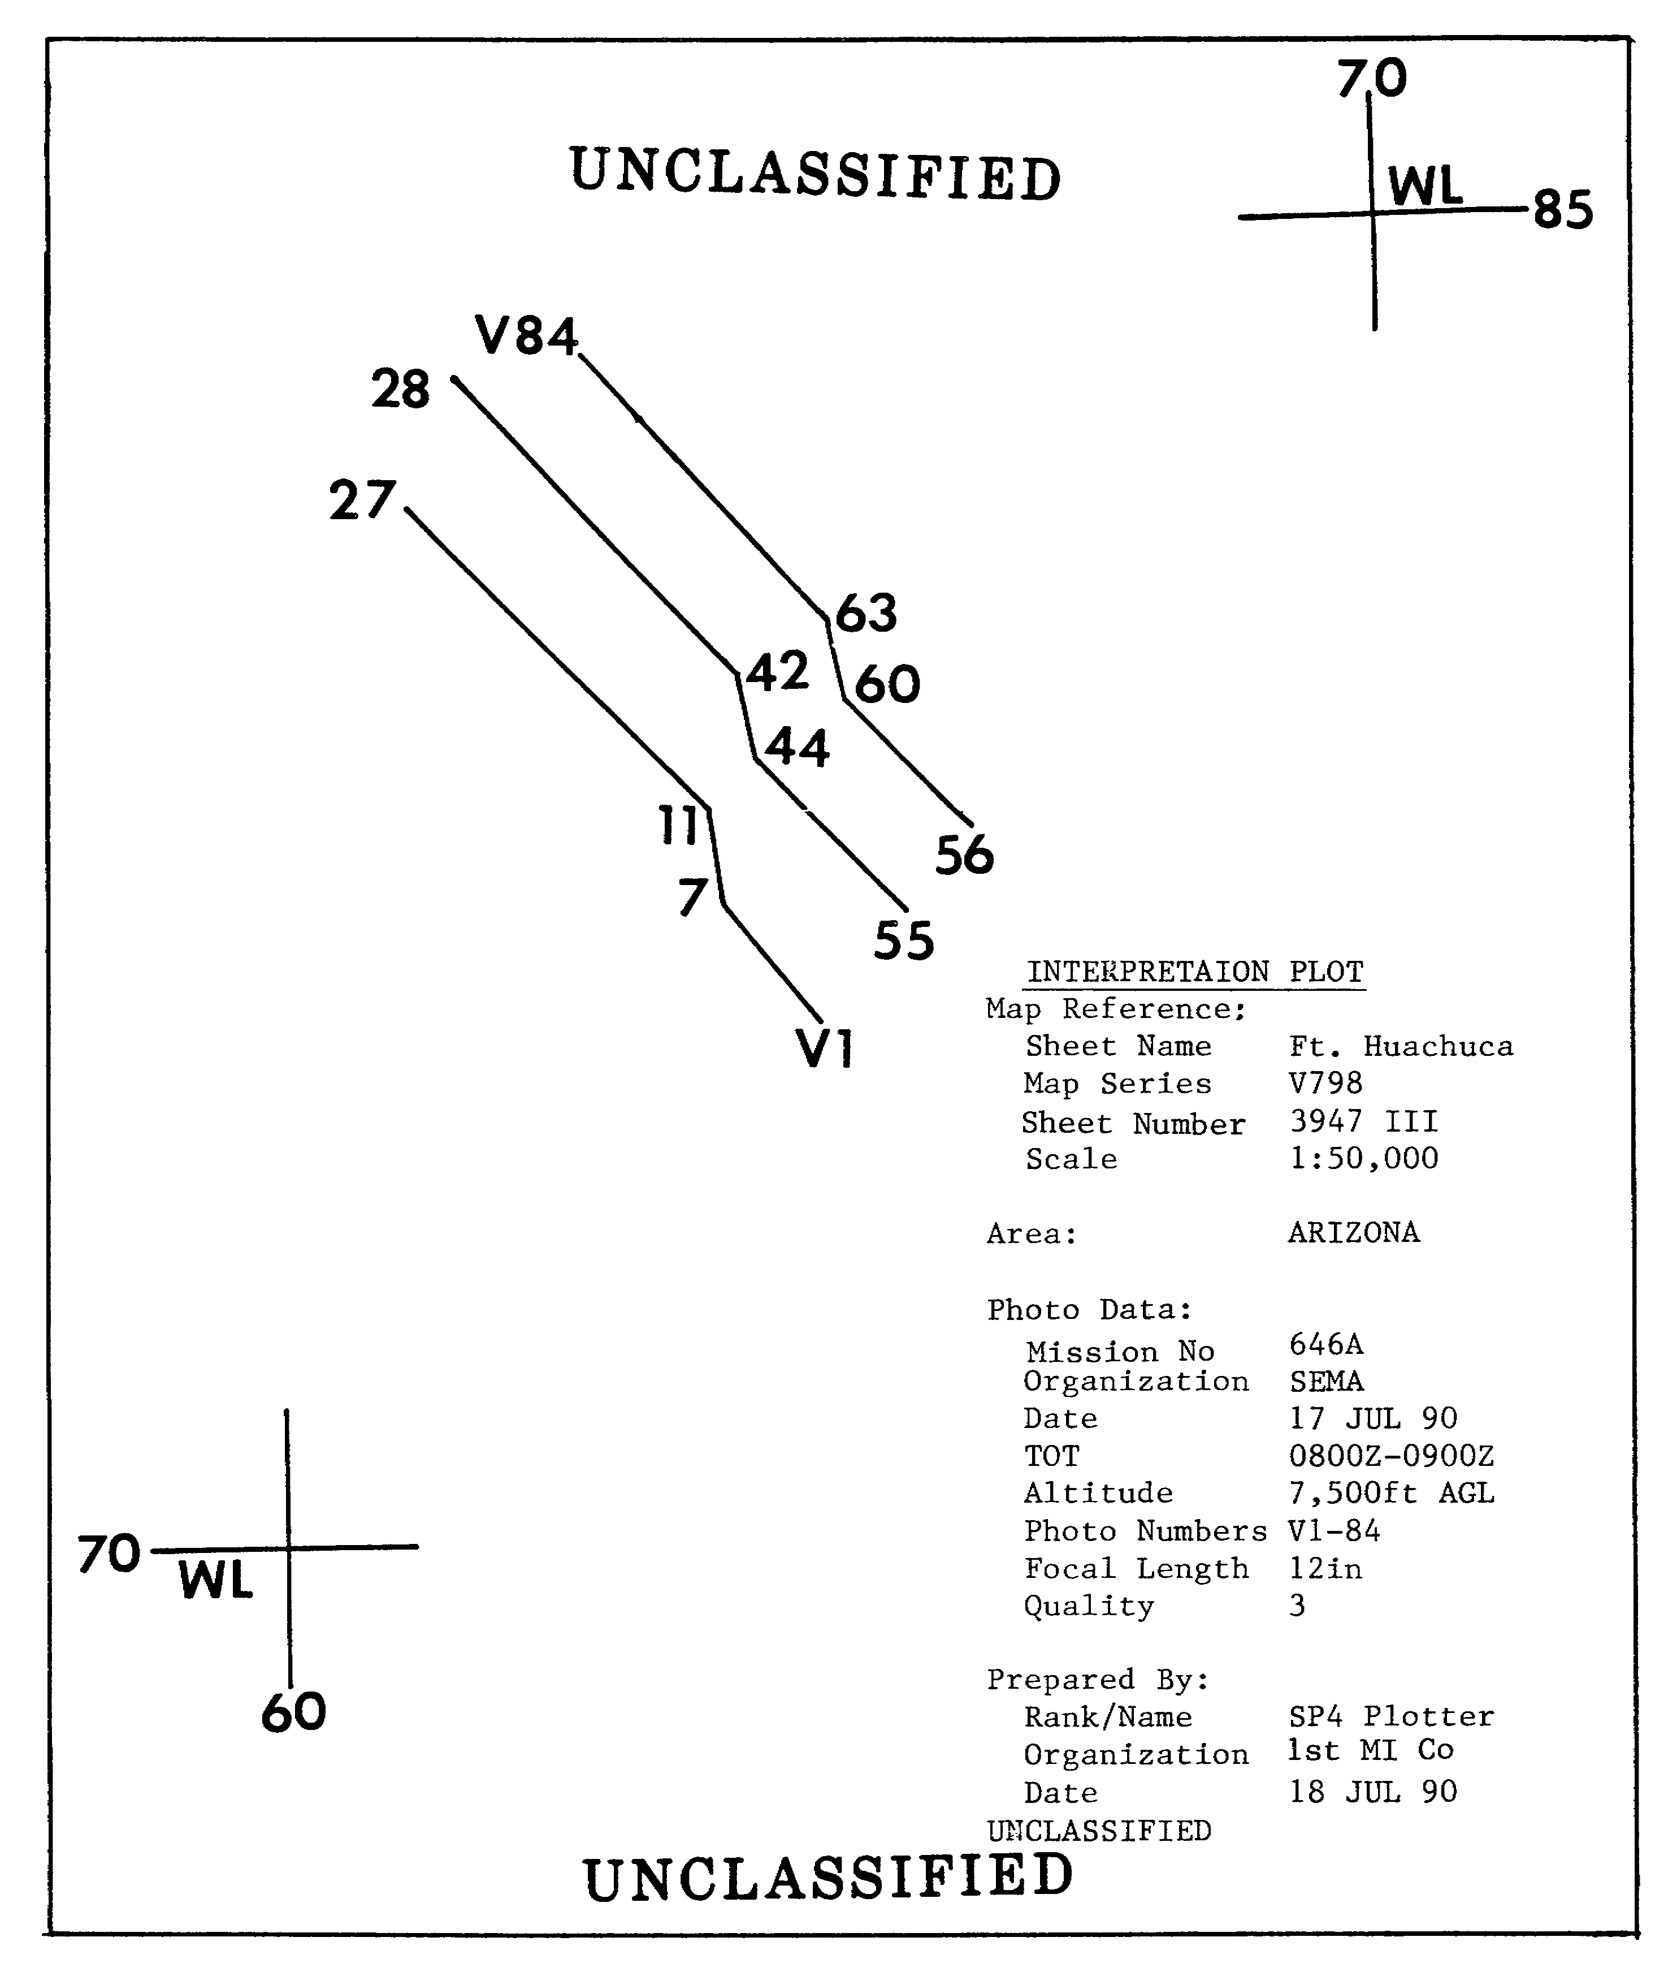

Figure 1-10. Interpretation Plot--Flight Line Method.

13 IT 0646

b. Strip method is the most commonly used method. It usually accompanies detailed reports. It shows a general outline or the area covered by each flight line. The strip method is prepared by plotting first, last, and turn frames, then connecting the outer edges by straight lines to show continuous coverage. Sidelap is indicated by a dashed line. Frame position is shown by the frame number (Figure 1-11).

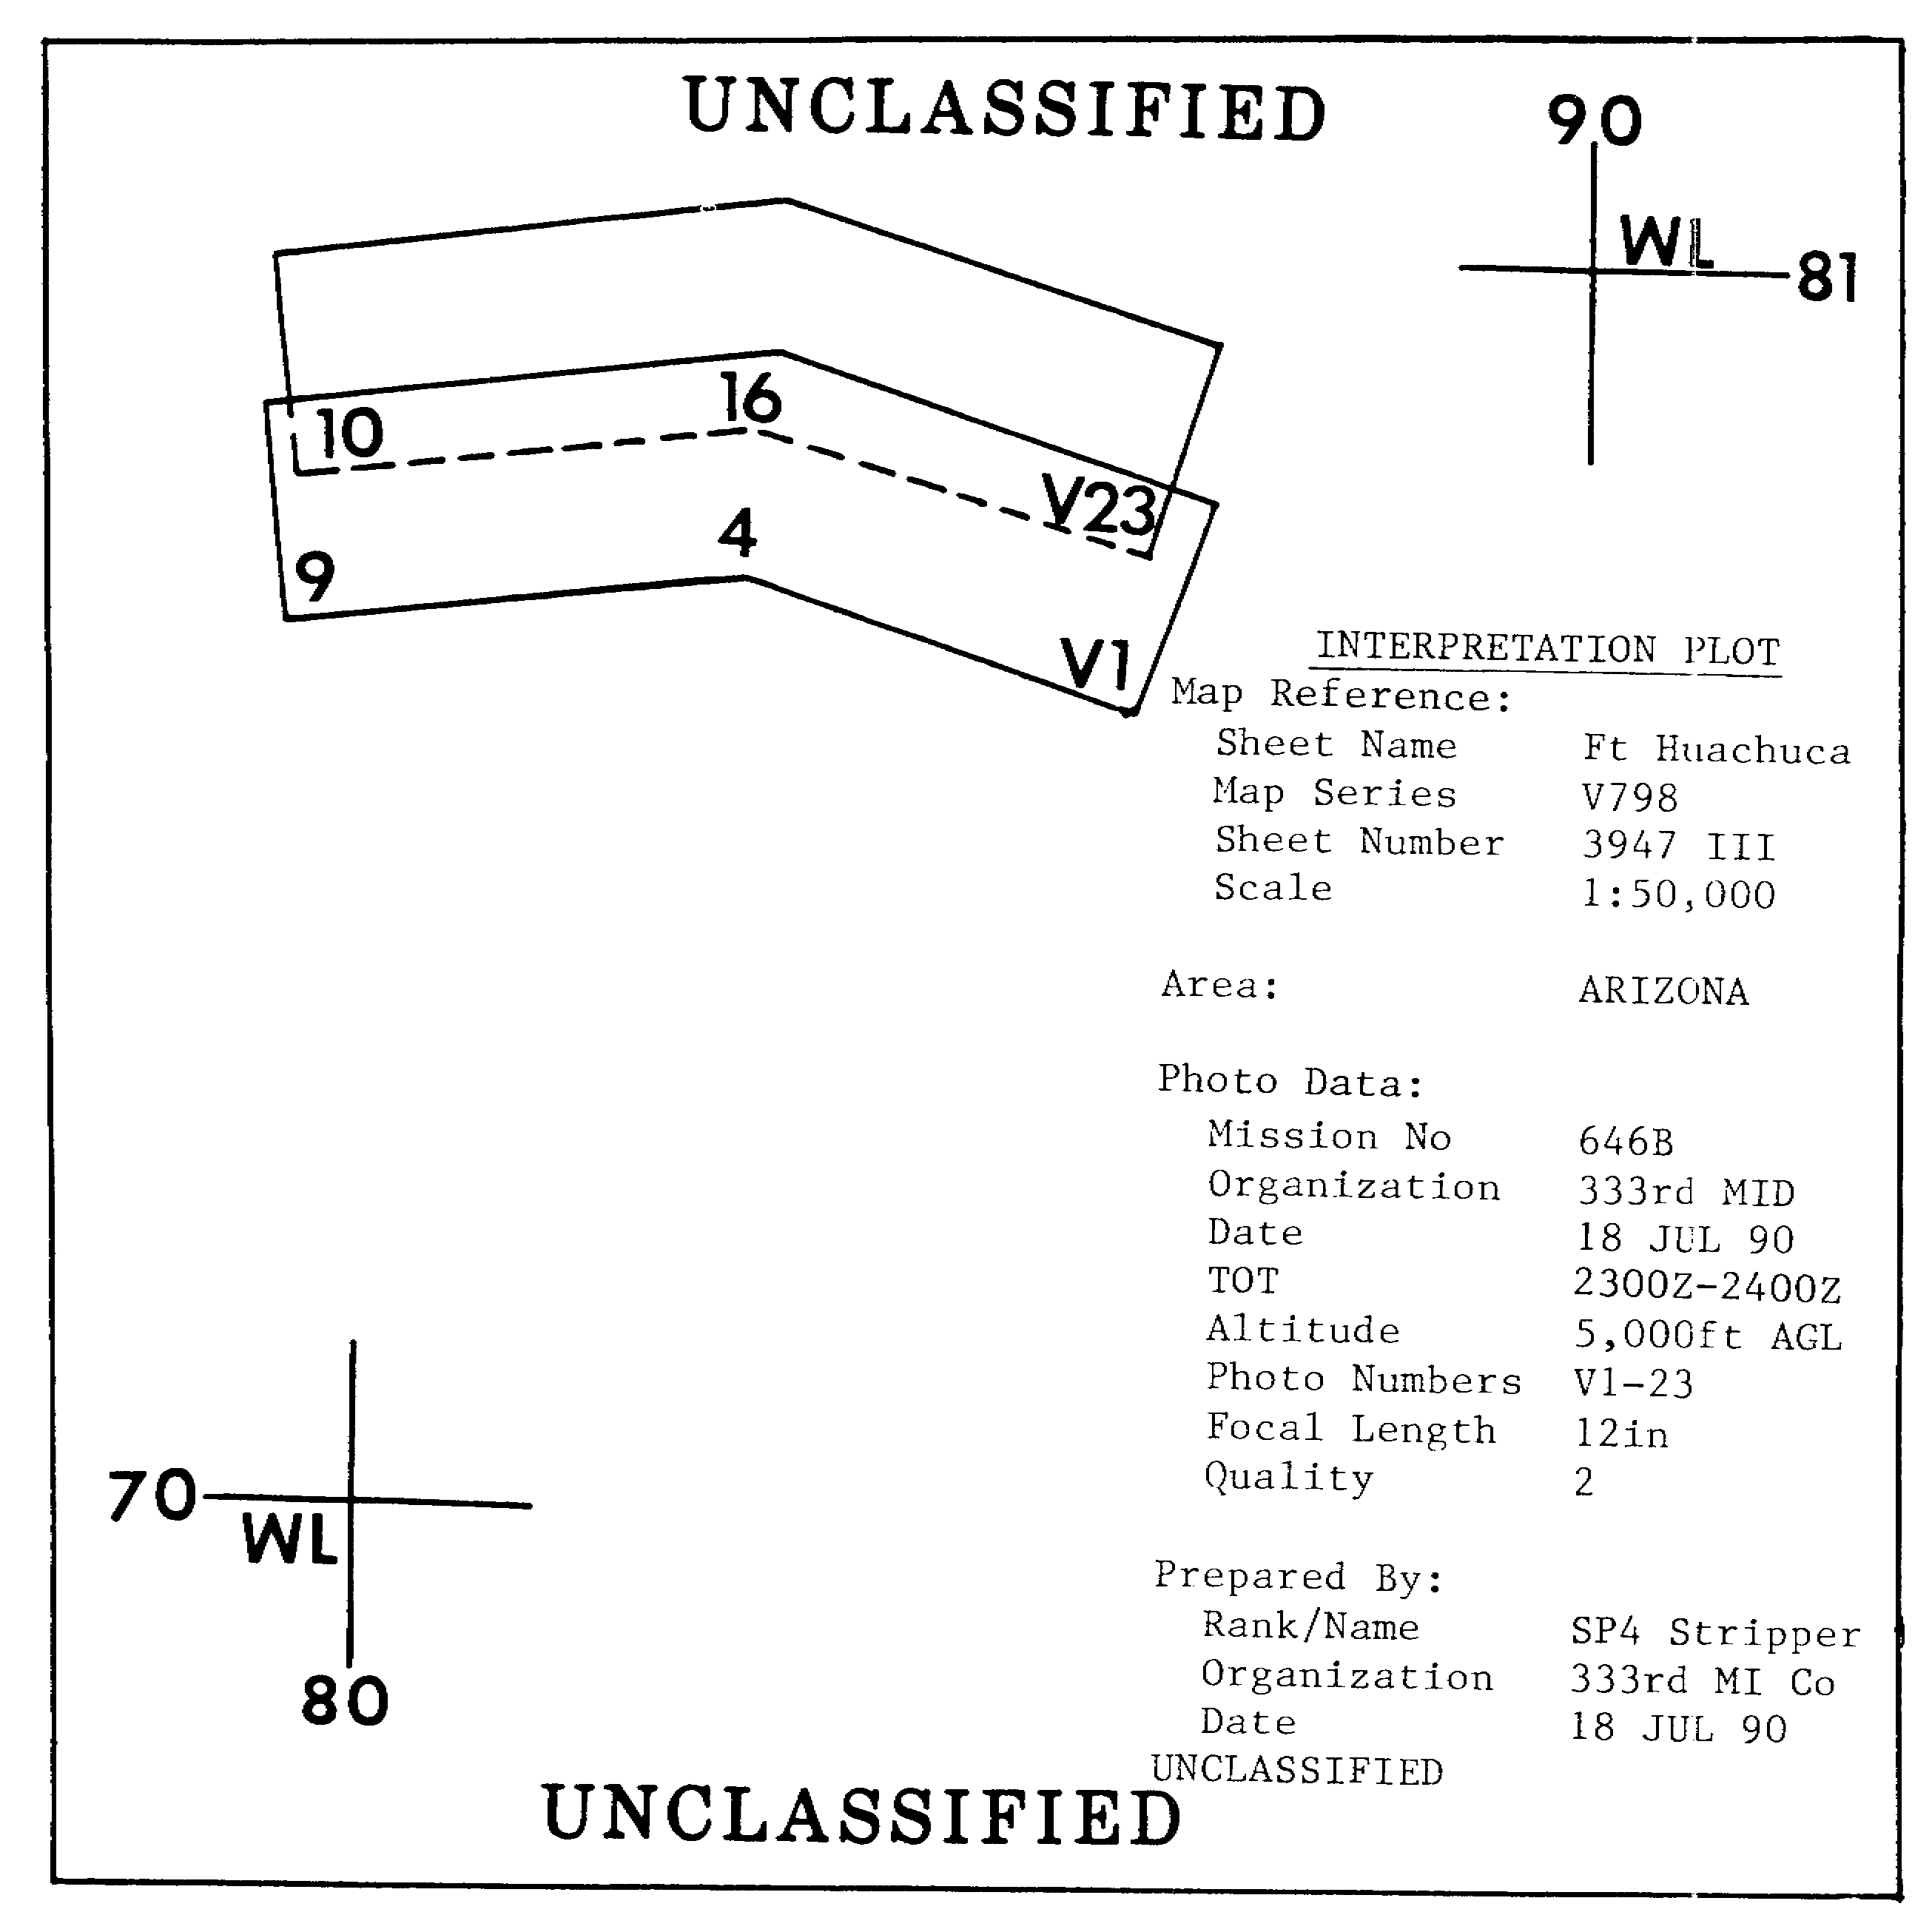

Figure 1-11. Interpretation Plot--Strip Method.

IT 0646 14

c. Individual photo method is the most accurate and time consuming method. It shows all photo coverage with an accuracy of 100m per frame plot. First and last frames of flight lines are drafted in solid lines. Where intermediate frames overlap preceding flight lines, dashed lines will be used. If all frames are not plotted, continuous coverage is indicated by extending a line from the center of the first frame's leading edge to the center of the next frame's trailing edge. Frame numbers will be placed inside the plot in a readable position, in the same portion of each frame. Should a flight line extend to another map sheet, an arrow will be extended from the last plotted frame on that map (Figure 1-12).

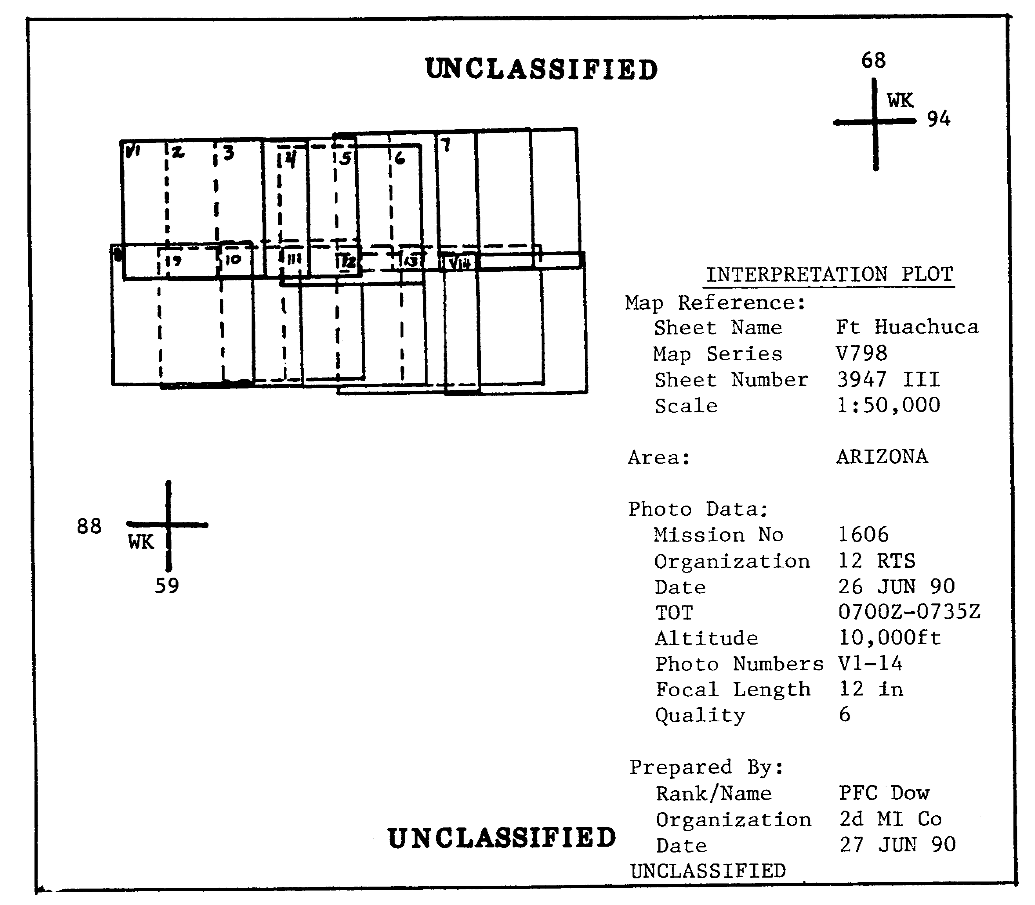

Figure 1-12. Interpretation Plot--Individual Photo Method.

15 IT 0646

PART F: PLOTTING PROBLEMS

Vertical photos normally appear as a rectangle when plotted by the individual photo method; however, you may experience a few problems when the aircraft flying the mission cannot pursue a straight and level flight. The following conditions may alter the aircraft's flight path, thus causing a diverse plotting effect:

a. Drift. This condition will plot out as a stairstep effect and is caused by high winds blowing the aircraft off course. The nose of the aircraft remains at the same heading (Figure 1-13).

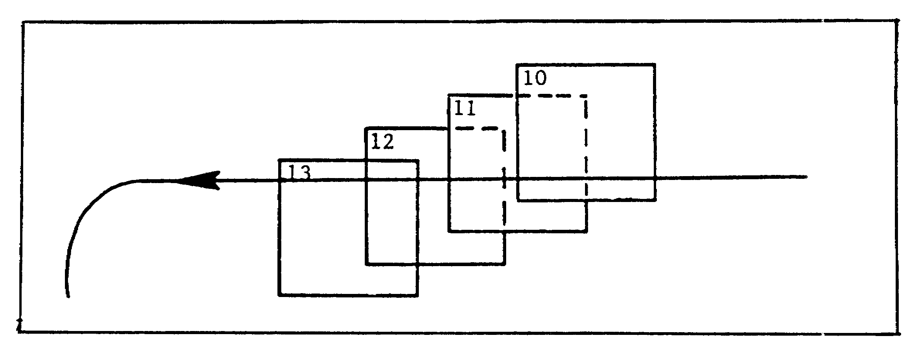

Figure 1-13. Drift.

b. Crab is caused by a failure to orient the camera to the direction of the aircraft. In attempting to compensate for the wind, the pilot turns the nose of the aircraft into the wind, thus twisting the plot of the photo coverage (Figure 1-14).

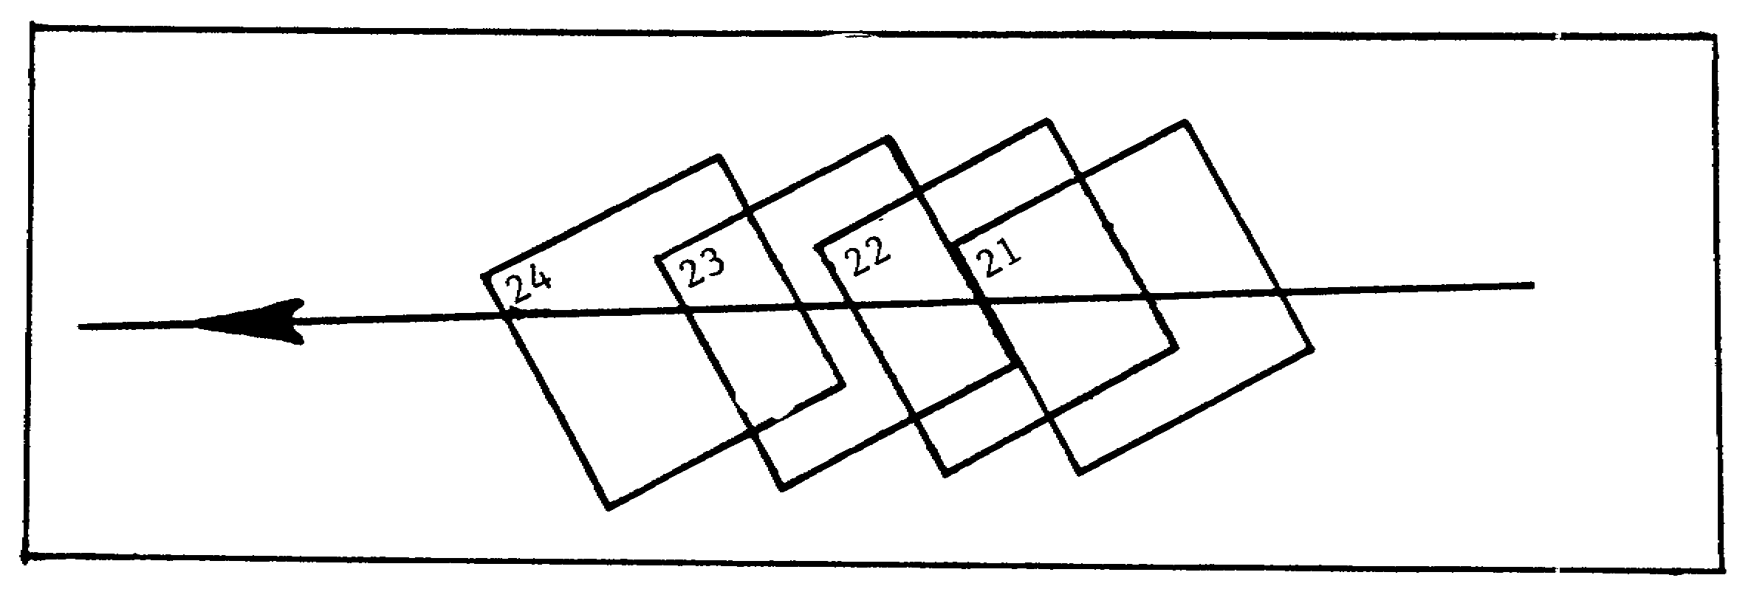

Figure 1-14. Crab.

IT 0646 16

c. Roll is caused by wind, up- or down-drafts, and/or aircraft maneuvers. The aircraft wings tilt, thus causing the imagery to be oblique rather than vertical (Figure 1-15).

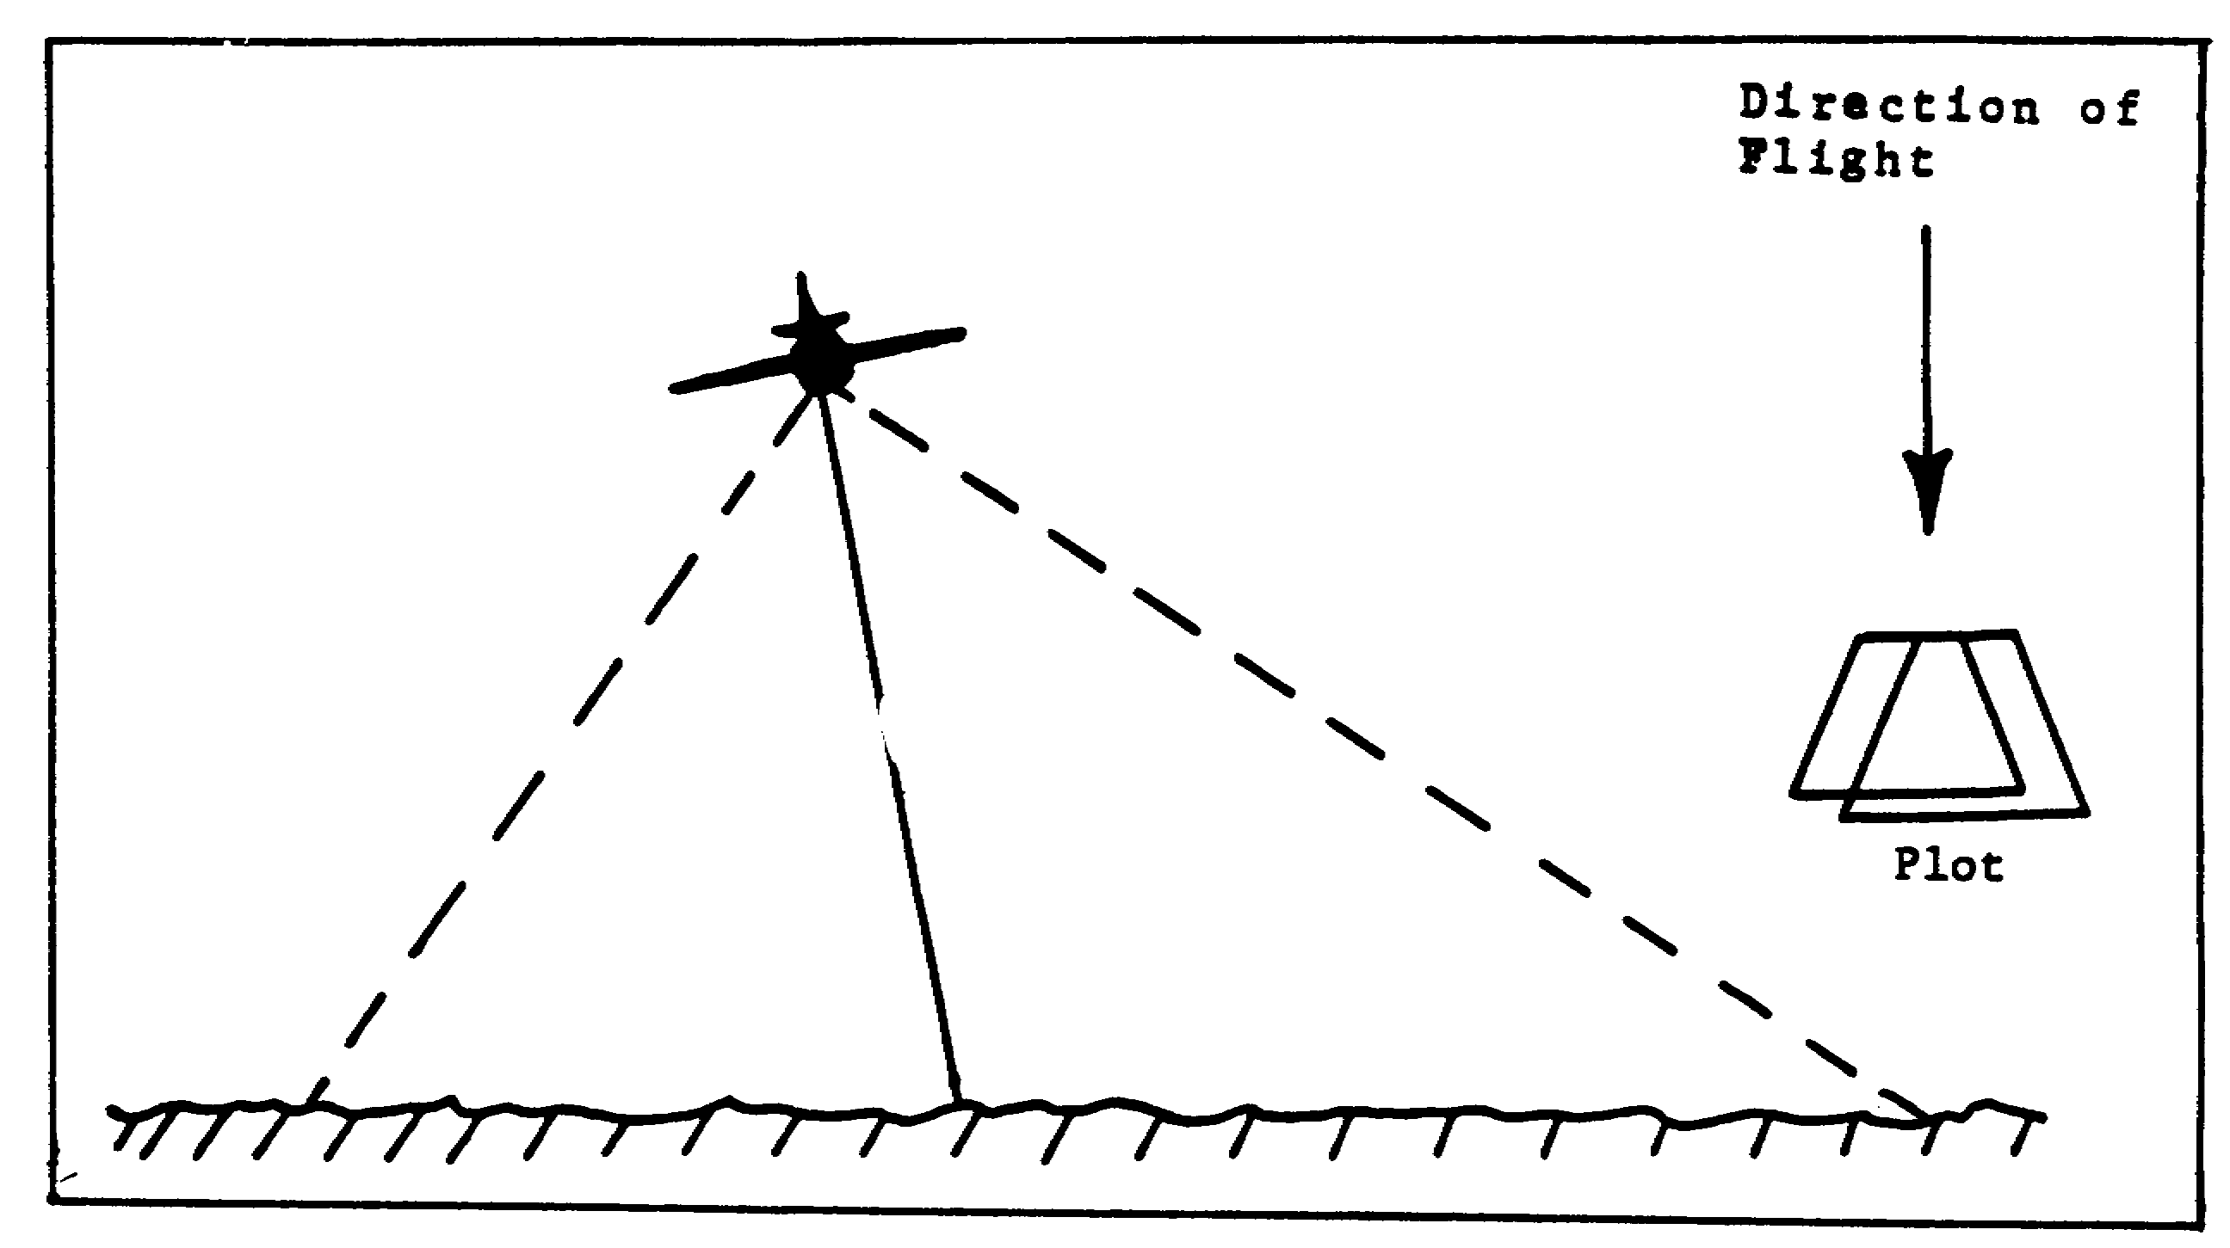

Figure 1-15. Roll.

d. Pitch causes the same effect as roll. This occurs when the aircraft nose tilts up or down (Figure 1-16).

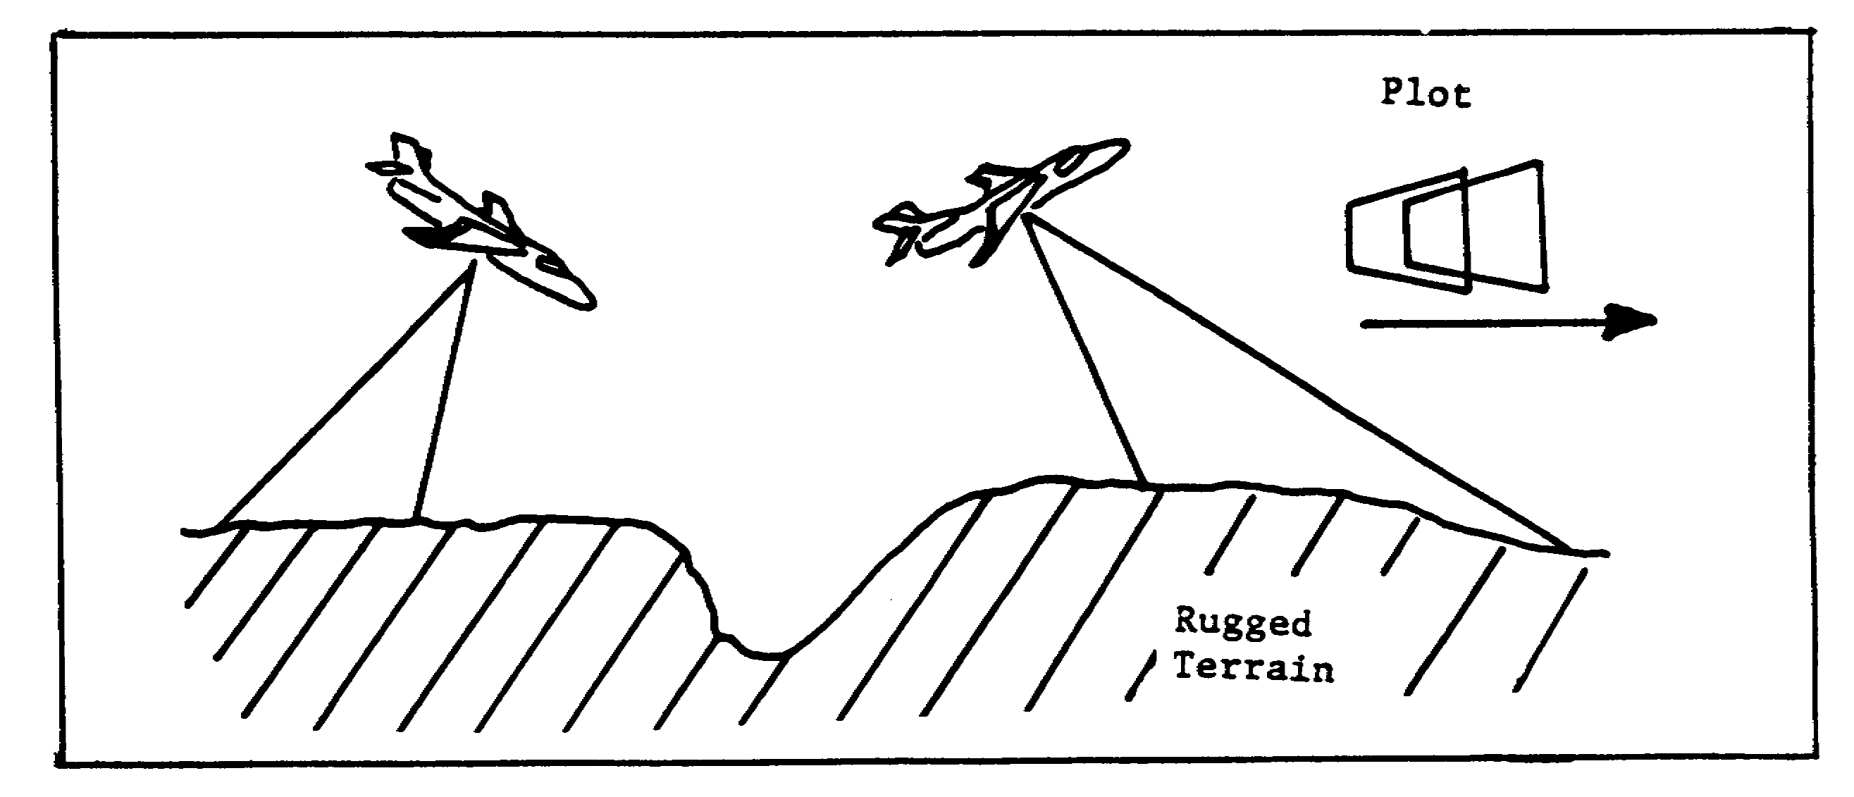

Figure 1-16. Pitch.

17 IT 0646

LESSON ONE

PRACTICE EXERCISE

The following questions will test your grasp of the material covered in this lesson. There is only one correct answer to each question. When you have completed the exercise, check your answers with the answer key that follows. If you answer any question incorrectly, study again that part of the lesson which contains the portion involved.

1. Who prepares the pilot's trace?

A. IA.

B. Pilot or air crew.

C. Air Reconnaissance Liaison Officer.

D. Intelligence Officer.

2. Where is the trailing edge of a plotting frame located?

A. Toward the flight direction.

B. To the right of the flight direction.

C. To the left of the flight direction.

D. Away from the flight direction.

3. What should you write in the top left of the first vertical frame of a field plot?

A. 1.

B. V.

C. V1.

D. 1V.

IT 0646 18

4. What causes a failure to orient the camera to the direction of the aircraft?

A. Crab.

B. Pitch.

C. Drift.

D. Roll.

5. How accurate should you plot when using the individual photo method?

A. 1m.

B. 10m.

C. 100m.

D. 1,000m.

6. When using the flight line method, you show what coverage?

A. Full area of coverage.

B. Overlap and sidelap.

C. Length of coverage.

D. Width of coverage.

19 IT 0646

LESSON ONE

PRACTICE EXERCISE

ANSWER KEY AND FEEDBACK

Item Correct Answer and Feedback

1. B. The pilot or air crew usually prepares the pilot's trace (page 3, para 1a).

2. D. The trailing edge of a plotting frame is away from the leading edge (page 6, para 1/fig 1-5).

3. C. V1 must be written in the top left corner of the first vertical frame of a field plot (page 8, para 1/table 1-1).

4. A. Crab causes failure to orient the camera to the direction of the aircraft (page 16, para b/fig 1-14).

5. C. Photo frame is plotted with an accuracy of 100m (page 15, para c).

6. C. The length of coverage is shown when plotting the flight line method (page 12, para 2a).

IT 0646 20

LESSON TWO

VERTICAL AERIAL PHOTO PLOTTING

MOS Manual Tasks: 301-338-1609
301-338-3701

OVERVIEW

TASK DESCRIPTION:

In this lesson you will learn to use the inspection, plotting template, point inspection, and proportional divider methods in plotting vertical aerial photos.

LEARNING OBJECTIVE:

ACTIONS: Use the inspection, plotting template, point inspection, and proportional divider methods in plotting vertical aerial photos.

CONDITIONS: You will be given access to extracts from FM 21-26, STP 34-96D1-SM, and TC 34-55.

STANDARD: You will use the inspection, plotting template, point inspection, and proportional divider method in plotting vertical aerial photos in accordance with FM 21-26, STP 34-96D1-SM, and TC 34-55.

REFERENCES: The material contained in this lesson was derived from the following publications:

FM 21-26
STP 34-96D1-SM
TC 34-55.

INTRODUCTION

In plotting vertical aerial photos, you can use the inspection, plotting template, point inspection, and proportional divider methods. There is no standard rule which method should be used; therefore, it is up to the individual IA.

21 IT 0646

PART A: INSPECTION METHOD

1. The inspection method is mostly used by IAs. Use photo V1 and the Fort Huachuca map and follow the steps which will guide you through a typical plotting effort in the inspection method. Refer to the graphics indicated in the steps.

a. Step 1: Orient the photo to the map (Figure 2-1). Remember, the shadows fall generally NORTH on your photos in the northern hemisphere. Locate the area covered by the photo. The pilot's trace (Figure 2-2) furnished with the mission should get you in the "ballpark."

b. Step 2: Loosen the locking nuts on your plotting template (Figure 2-3) and place the template over the area covered on your map. Adjust the template until the coverage within the template matches that shown on the photo (Figure 2-4).

IT 0646 22

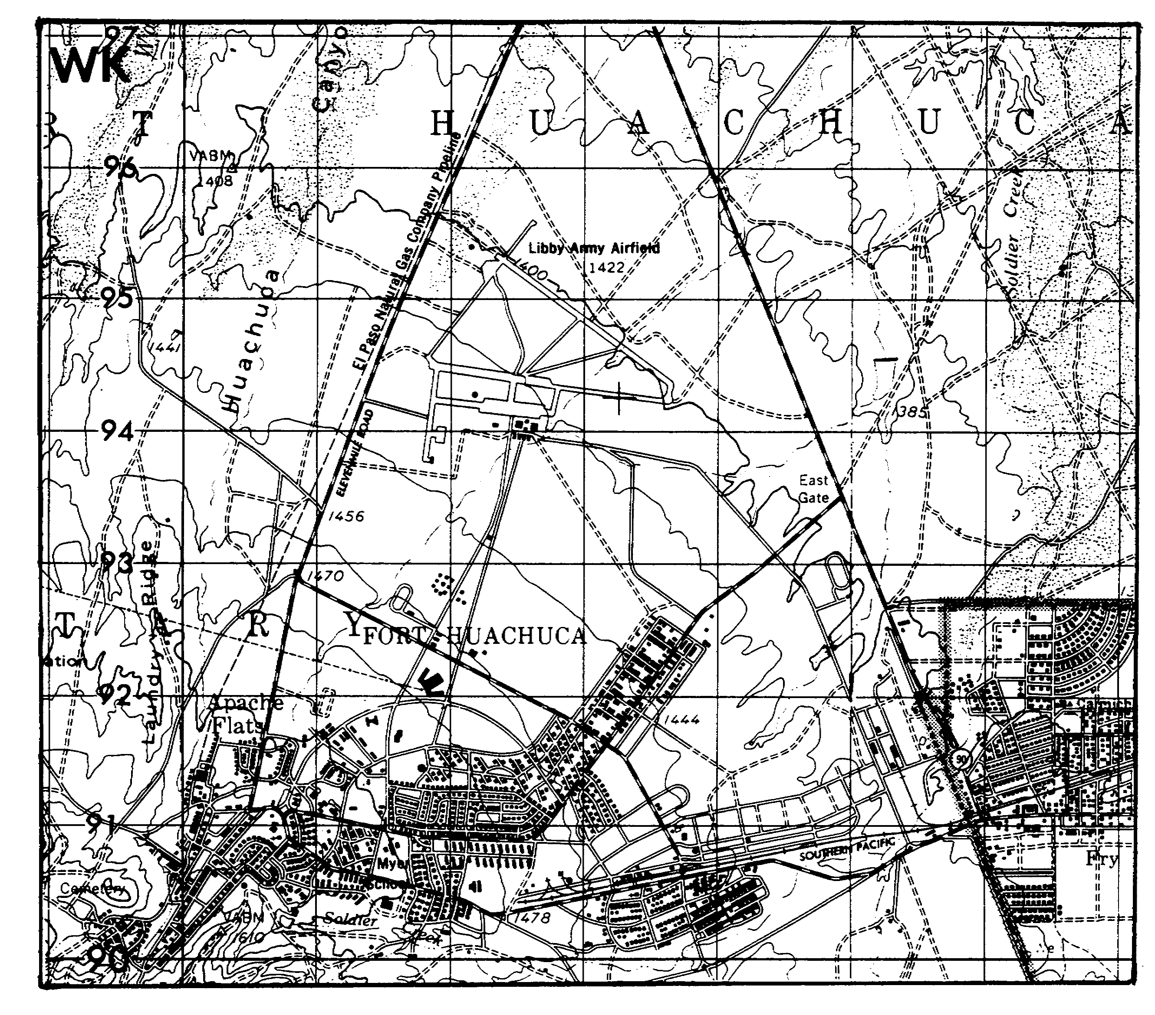

Figure 2-1. Fort Huachuca Map Extract.

23 IT 0646

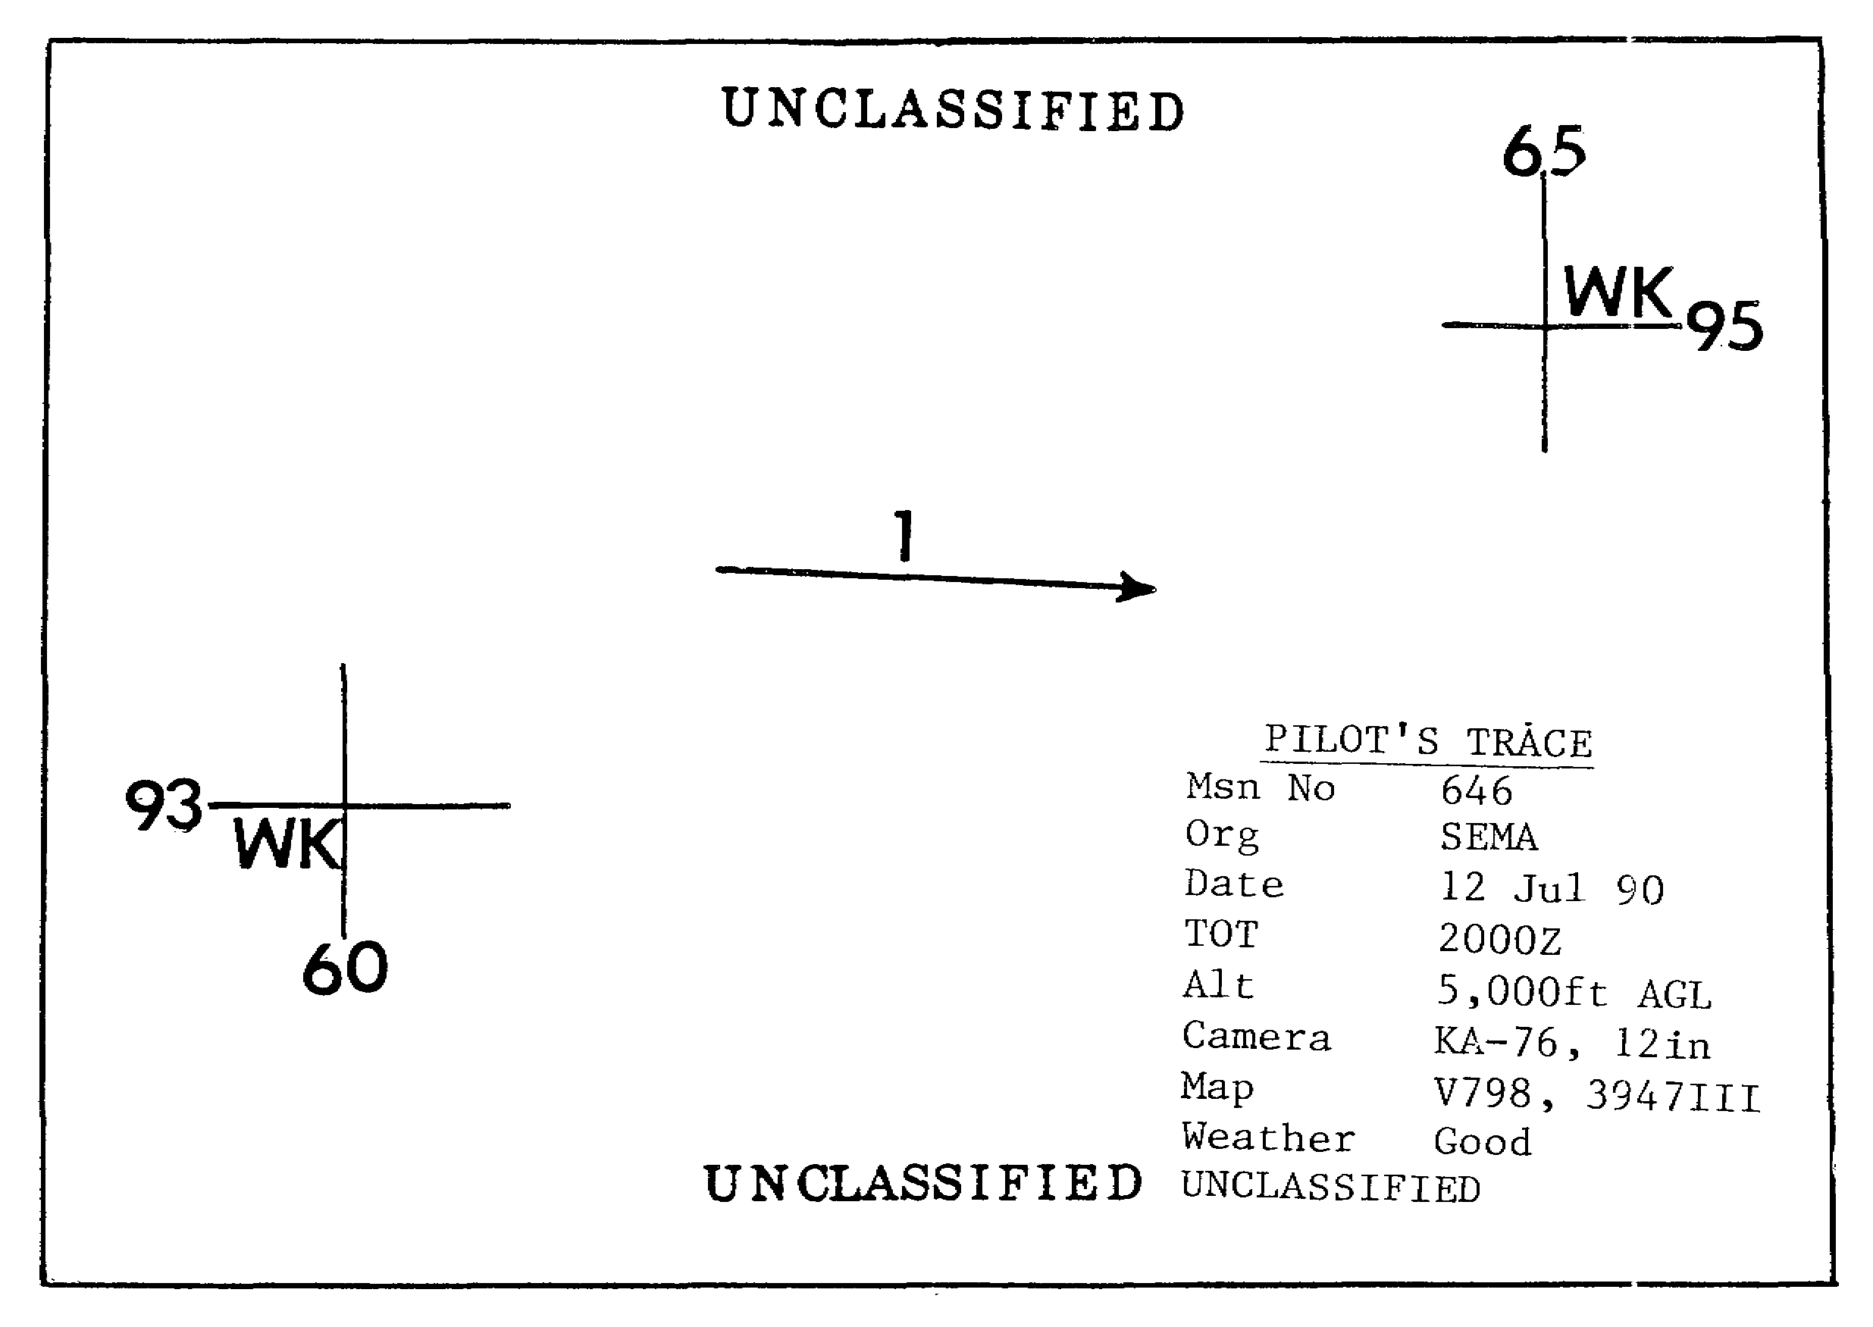

Figure 2-2. Pilot's Trace.

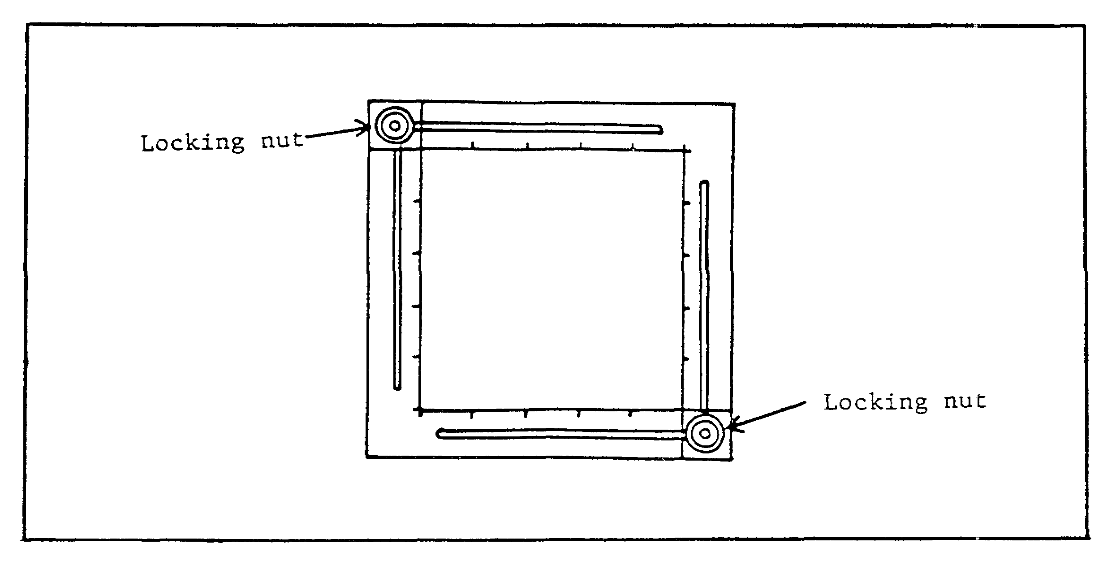

Figure 2-3. Plotting Template.

IT 0646 24

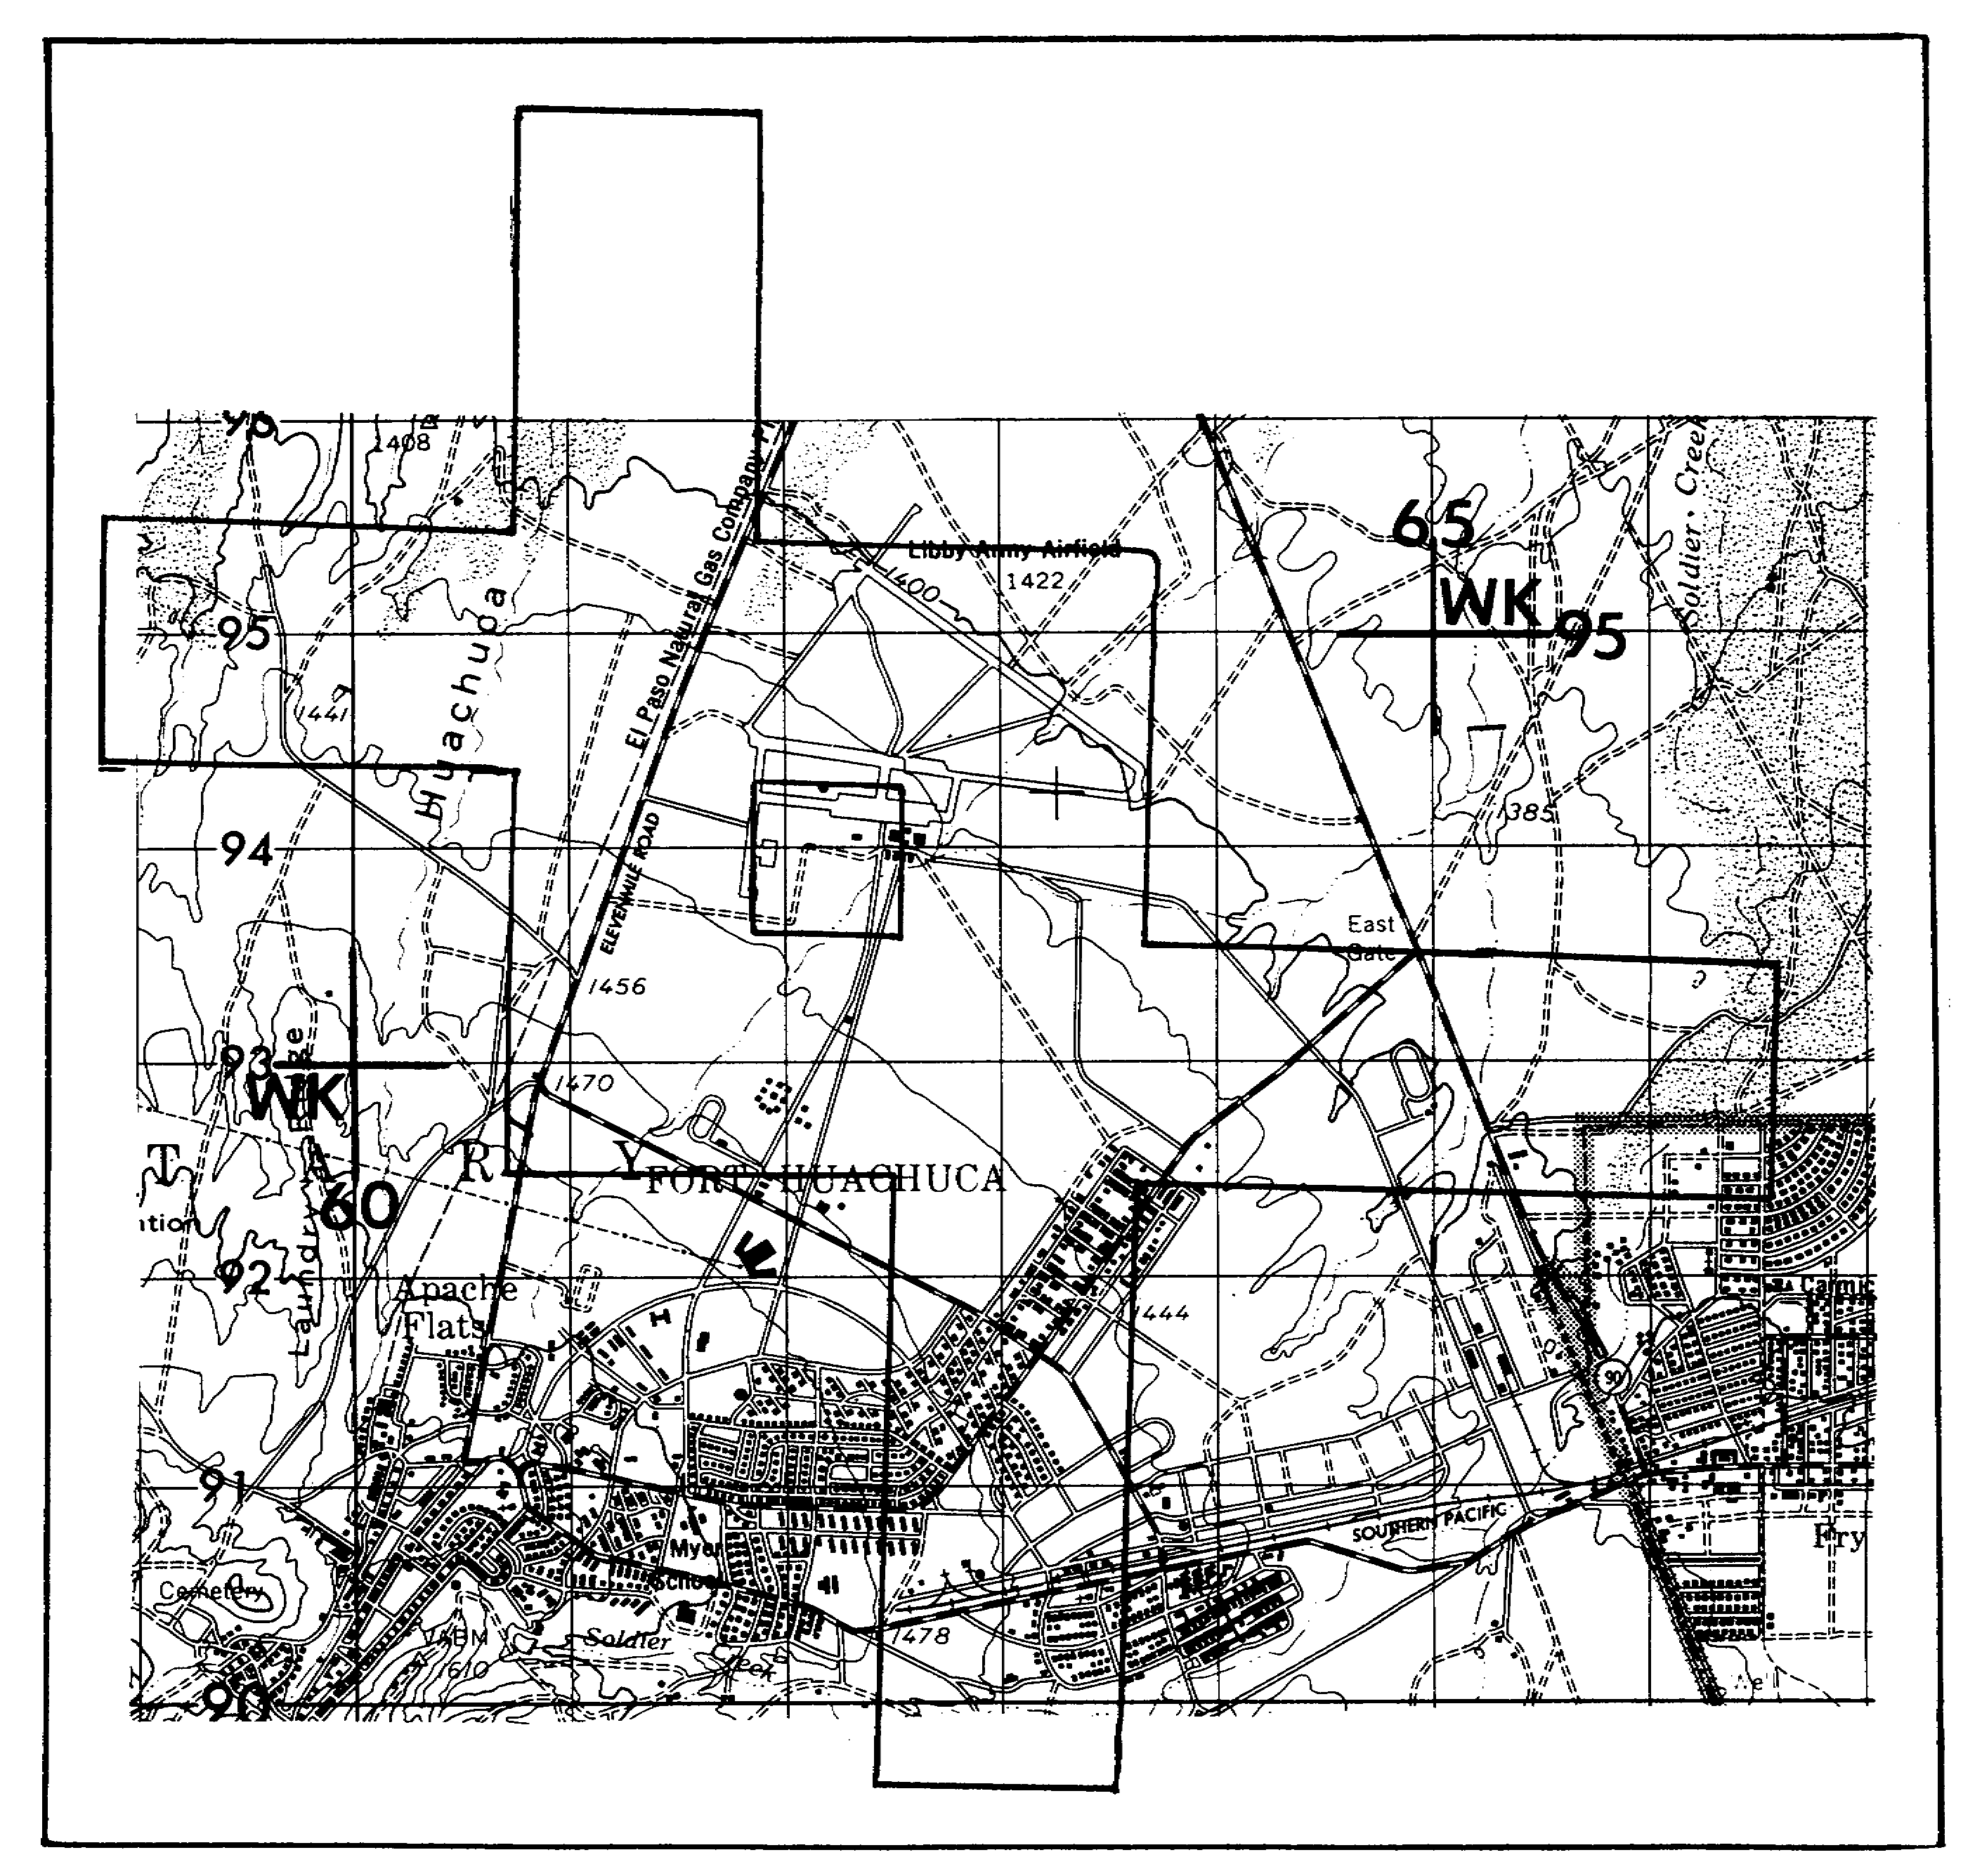

Figure 2-4. Plotting Template Superimposed
over Area Covered on Map.

25 IT 0646

NOTE: In attempting to orient the template, you should ensure the following:

- All features on the photo should appear within the template.

- Features within the plot are in their proper location with respect to the corners and borders of the plot.

- Manmade features are the easiest to plot. Buildings, highways, railways, and the like are normally located on maps with considerable accuracy. Another advantage is these features normally have not moved between the time of map compilation and the time the photo mission is flown.

- Topographic features are far more difficult to plot. Relief is a particular problem, because it is so difficult to identify the relief features. Use your stereoscope to prevent mistakes in relief identification.

c. Step 3: Tighten the locking nuts and use a sharp pencil to trace along the inner surface of the template, thus establishing the plot.

d. Step 4: Place the frame number in the plot.

2. Compare your photo to Figure 2-4, which shows a plotting template superimposed over the area of photo V1 covered on map. For stereoscopic viewing use photo 2.

PART B: PLOTTING TEMPLATE METHOD

1. The fastest and probably most hasty method in plotting vertical aerial photos is the plotting template method. Use the following sequence:

a. Step 1: Orient the photo to the map.

b. Step 2: Determine the photo scale and compute the template setting.

NOTE: Inspect your plotting template and note graduation is in inches, .1 and .05 inches, and millimeters (mm).

2. To determine the template setting, you must know the following:

a. Size of the photo/imagery frame

b. Scale of the photo/imagery frame

c. Scale of the map on which the photo is to be plotted.

IT 0646 26

3. Measure the photo size (PS) with an inch ruler and determine the photo scale from the marginal data. For example, if the focal length (f) is 3 in, and the radar altitude (H-h) is 2,500 feet (ft) using the formula f/H-h, you should arrive at a photo scale of 1:10,000.

4. The following terms must be considered to determine the template setting (TS): photo size (PS), denominator of the photo representative fraction (DPRF), and the denominator of the map representative fraction (DMRF). You find the map scale in the marginal data of the map. The DPRF is also known as the photo scale reciprocal (PSR) and the DMRF is also referred to as the map scale reciprocal (MSR). Use these terms in the formula:

TS = PS x DPRF
DMRF

a. For example, if PS = 9in x 9in, DPRF = 6,000, and DMRF = 50,000;

TS = PS x DPRF = 9in x 6.000 = 54,000 in = 1.08 in
DMRF 50,000 50,000

b. Therefore, the template setting (TS) = 1.08 in.

5. You can determine calculations by using a calculator, doing it longhand, or using the PI slide rule. Next, take out the slide rule and solve the following problem using the prescribed steps (Figures 2-5 through 2-7). For example, the scale of a 4 1/2in x 4 1/2in photo is 25,500, which is to be plotted on a 1:50,000 map. What is the template setting to the nearest inch?

a. Step 1: Using the focal length and altitude scales, move the cursor until the hairline falls on the DMRF (see arrow pointing to 50,000 or 50M in Figure 2-5).

b. Step 2: Move the slide until the photo size (4.5in cov(erage)) is under the hairline, directly adjacent to the DMRF (Figure 2-6).

c. Step 3: Holding the slide in place, move the cursor until the hairline is over the DPRF (25,500), on the altitude scale. The template setting will appear under the hairline on the focal length scale (Figure 2-7). Your reading to the nearest 1/10 of an inch is 2.295 or 2.3in.

27 IT 0646

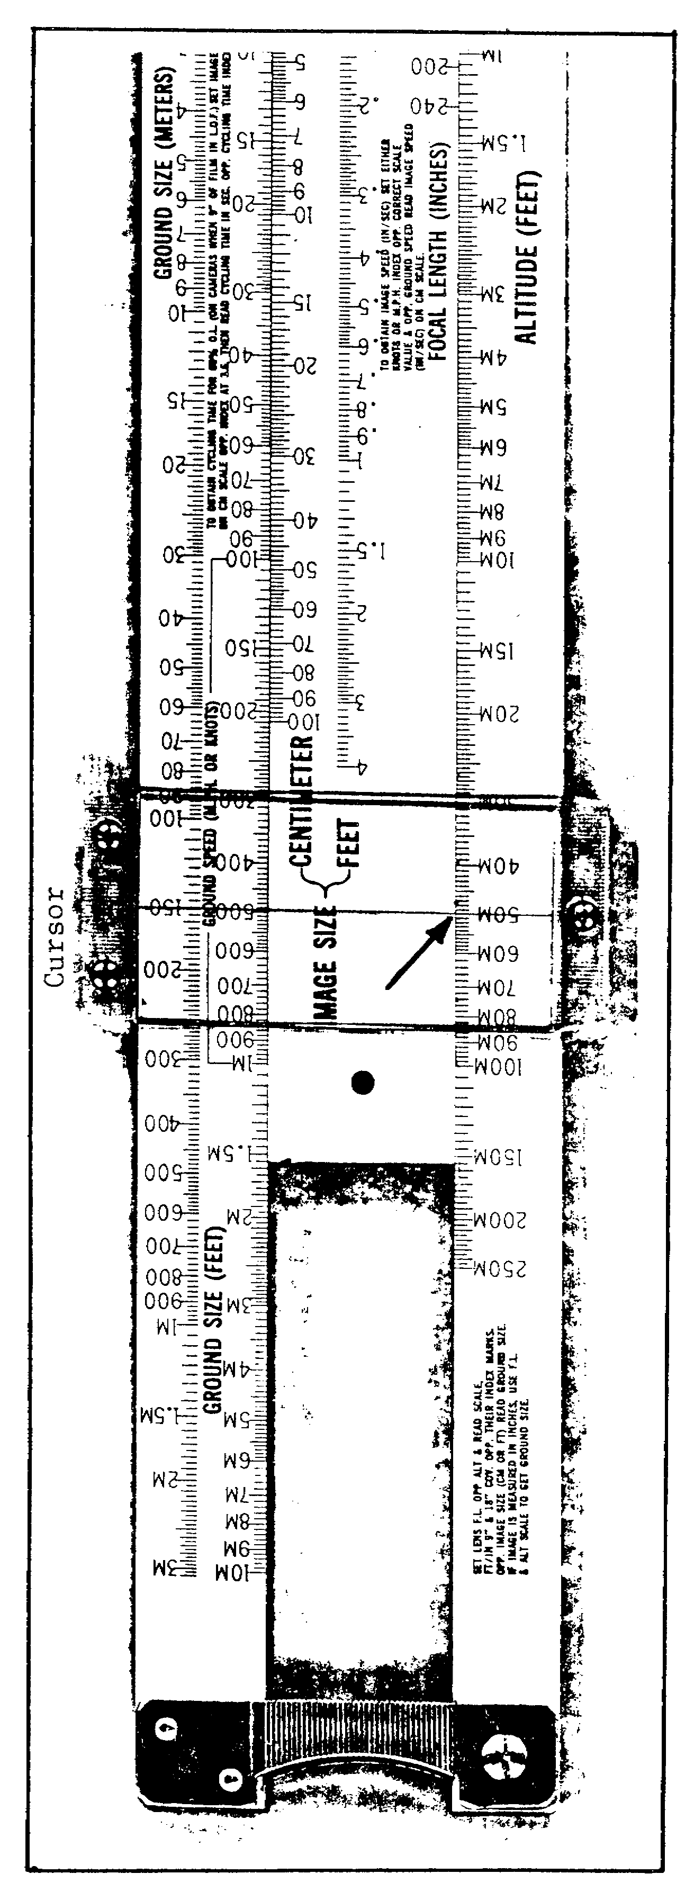

Figure 2-5.

IT 0646 28

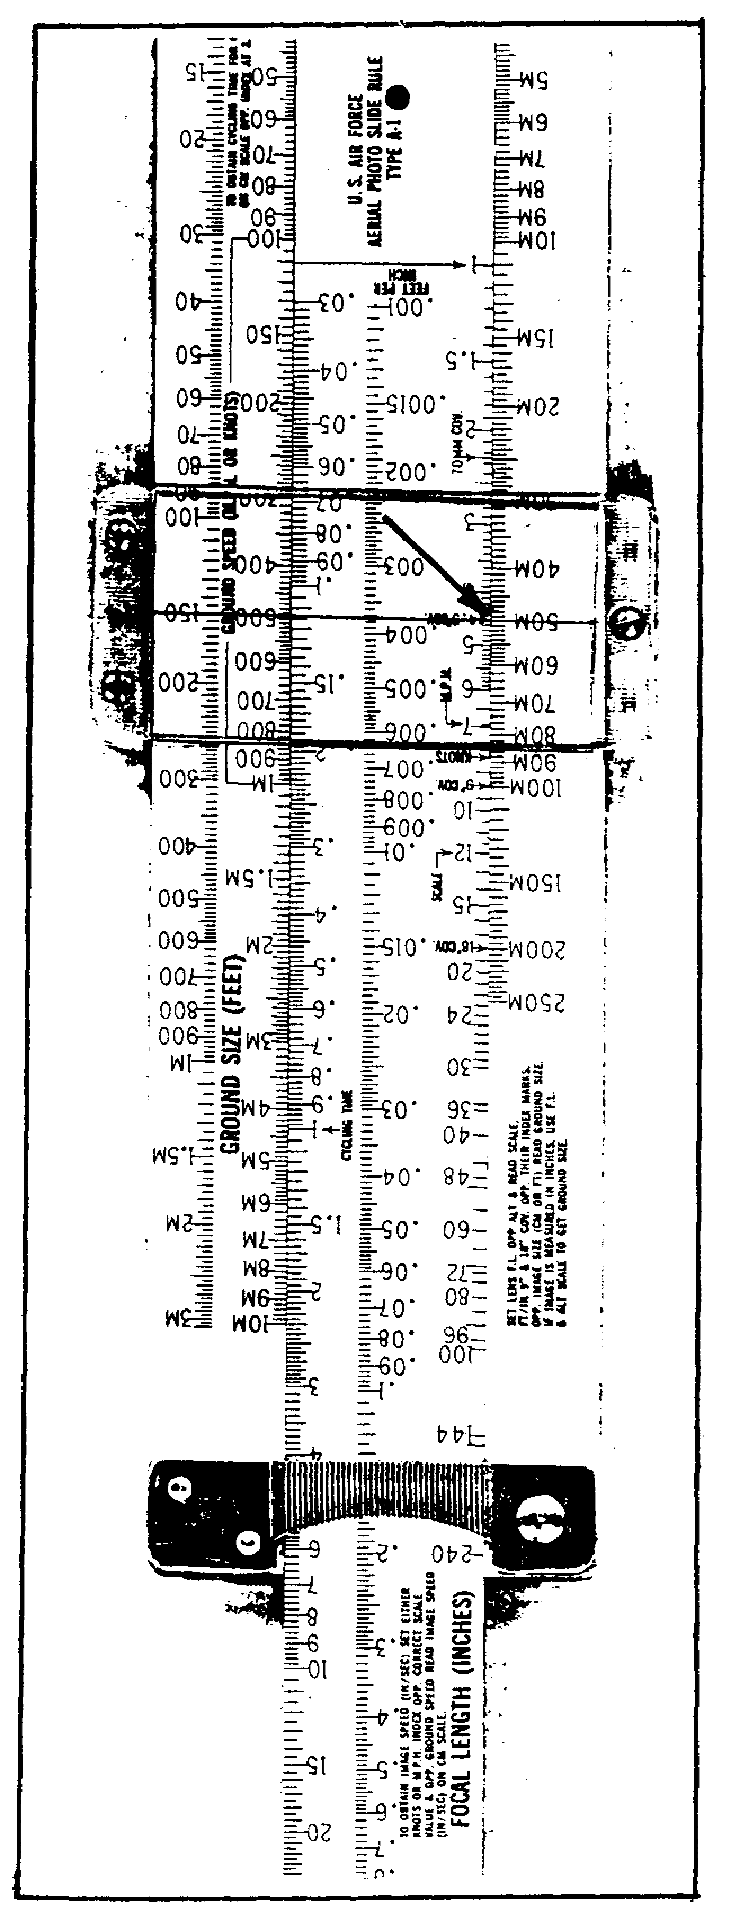

Figure 2-6.

29 IT 0646

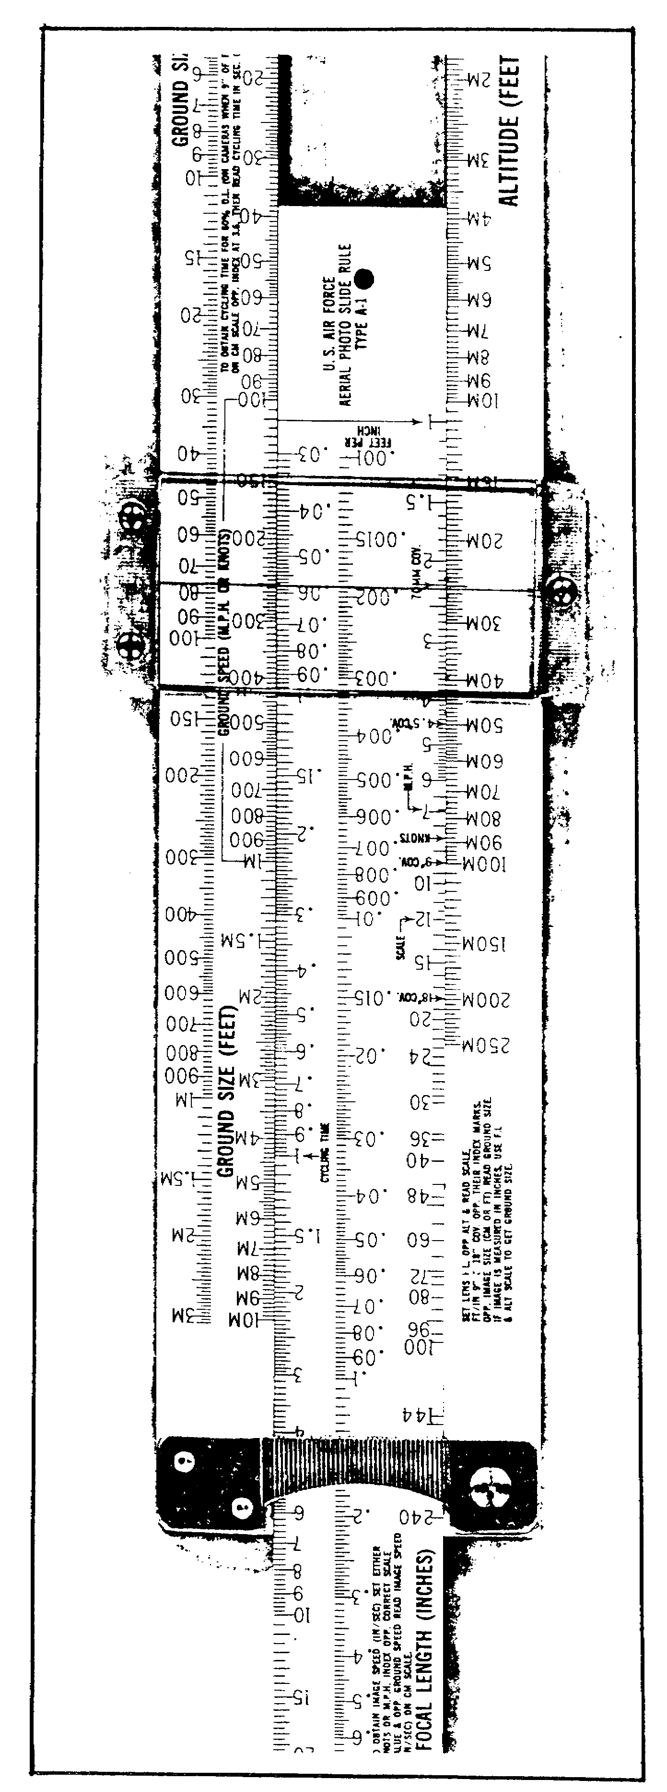

Figure 2-7.

IT 0646 30

d. Step 4: Adjust the template.

e. Step 5: Position the template over the area covered.

f. Step 6: Outline the area covered with a sharp pencil.

g. Step 7: Number the plot.

PART C: POINT INSPECTION METHOD

1. In the point inspection method you take two points along the photo side and accurately plot them on the map. Using a straight edge, extend a line through the points, thus plotting one side of the photo. See photo 4 and the map extract (Figure 2-8), both of which show Annotations A and B.

a. Annotation A on the top left corner of photo 4 depicts a building and the encircled Annotation A on the map extract (Figure 2-8) represents the same building.

b. Annotation B at the bottom left near the notched portion of photo 4 shows an asphalt road west of a junction; further north you should locate several buildings, some of which are depicted on the map extract (Figure 2-8). The corresponding point is shown on the map extract by an encircled Annotation B. By means of interpolation you should be able to plot the edge of the photo onto the map.

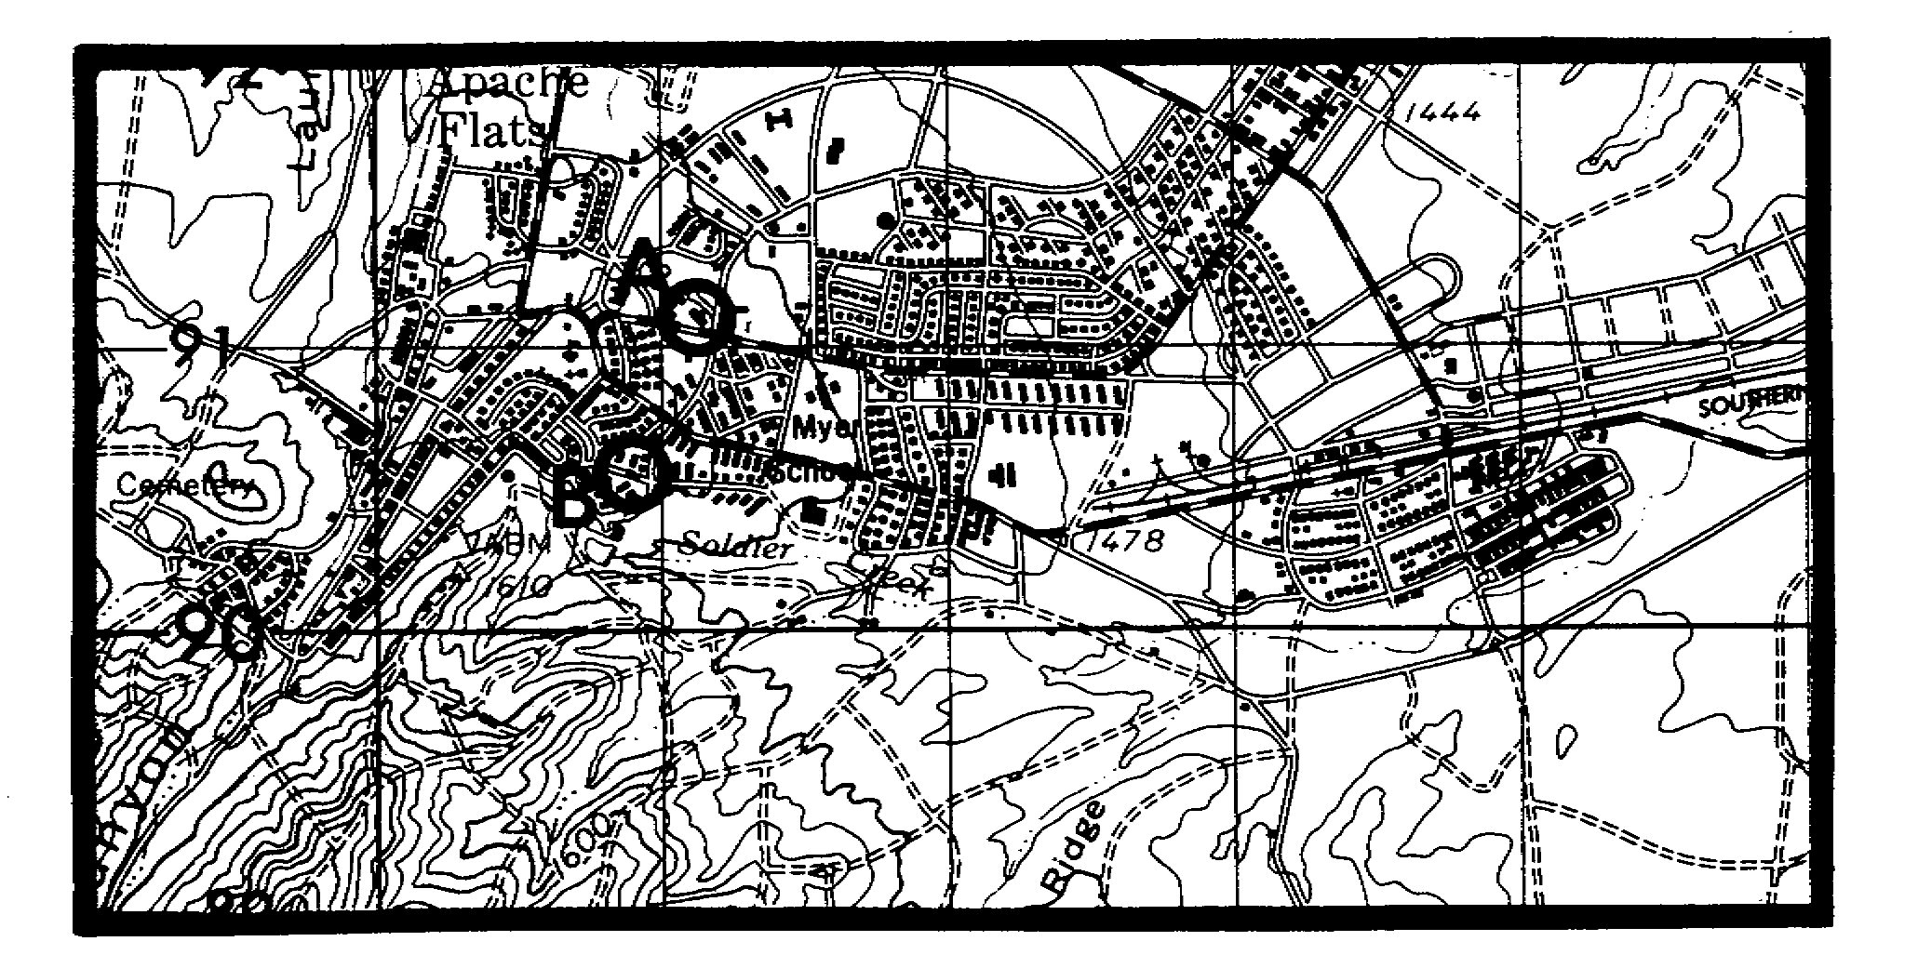

Figure 2-8. Map Extract.

31 IT 0646

2. After taking two points along the side of the photo, you must plot them accurately on the map and then draw a line through the points. This will constitute one side of the photo.

3. Next, you should repeat this sequence for all sides. The location of points requires a constant comparison of features appearing on the photo with their symbolic representation on the map. You should heed the following pointers in plotting from topographic features.

a. Use stereoscope whenever in doubt about relief.

b. Spurs will appear as Us with the curved portion leading uphill.

c. Ridge lines run along the highest points of ground and include hilltops, saddles, and spurs.

d. To facilitate orientation, trace spurs and draws with a grease pencil. To avoid confusion, use one type of line for the draws and another for ridge lines.

e. To estimate distances, you should use points where draws or ridge lines intersect. Do NOT try to estimate distances along hillsides or draws.

f. A stream or dry wash is usually plotted accurately on your map. However, they tend to meander or change shape In lowlands. This s caused by rising and falling water levels and erosion.

(1) if water levels are higher on the photo than on the map, trace the new water level on the map with a blue grease pencil.

(2) Where streams meander, try to locate the old course and use it for Identification and location.

(3) It a totally new wash or stream appears and the old course cannot be identified, relate the wash to a draw running in the same area. Streams usually form in low areas like draws.

(4) If a stream has developed in a draw, update the map.

g. Tree formations are usually accurately plotted and easy to relate to the map. Lumber operations or tires may alter the shape, but the ghost of the old tree line is often still quite visible.

IT 0646 32

PART D: PROPORTIONAL DIVIDER METHOD

1. The proportional divider is an adjustable, drafting compass-like instrument designed especially for enlarging or reducing drawings and sketches proportionally. Furthermore, it is used for transferring objects from aerial photos to maps. The proportional divider may be used with any scale for making measurements. The two scales along the sides of the divider are identical, except the left side is used to increase or decrease linear distances proportionally; the right side is used to increase or decrease the circumference of circles (Figure 2-9).

2. The proportional divider may be adjusted by using the inspection method or the formulas--

a. Divider setting = photo distance (PD) + map distance (MD) = PD
MD

b. Divider setting = map distance (MD) + photo distance (PD) = MD
PD

c. Divider setting = photo scale reciprocal (PSR) + map scale reciprocal (MSR)

= PSR or DPRF
MSR DMRF

d. Divider setting = MSR or DMRF
PSR DPRF

NOTE: For all of the above formulas, you must reduce the fraction to a numerator or denominator of 1.

e. For example, the distance on a map from one intersection to another is 2 centimeters (cm); on the photo, the same stretch measures 4cm. What is the divider setting?

Divider setting = 2 = 1 : 2 (Figure 2-10). Set index line on 2.
4
f. Another example: A photo with a scale of 1:10,000 is to be plotted on a 1:50,000 map. What is the divider setting?

10,000
Divider setting = 50,000 = 1 : 5. Set index line on 5.

NOTE: You must use all measurements on the same basis, i.e., use only inches, centimeters, millimeters, or the metric scales of the engineer scale. Remember, 10mm = 1cm.

33 IT 0646

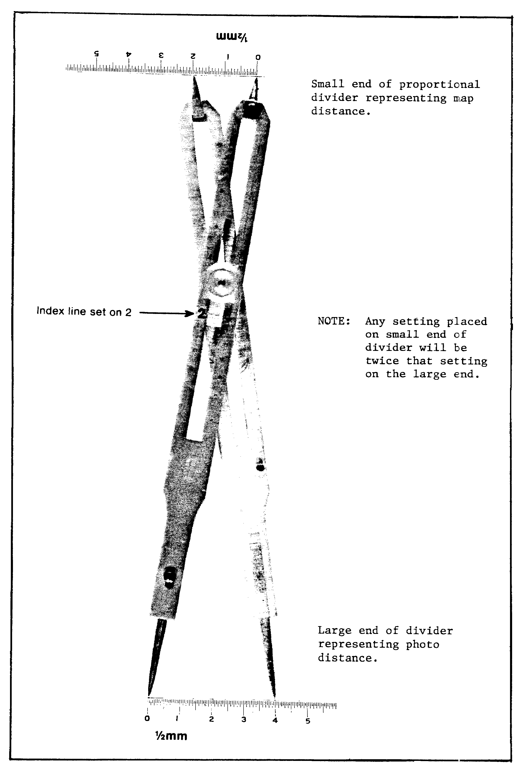

Figure 2-10. Proportional Divider Setting.

IT 0646 34

3. A typical method for plotting with the aid of a proportional divider is described below. The imagery for this example is the fixed target indicator (FTI) side of side-looking airborne radar (SLAR) imagery, which is similar to a vertical photo and for lesson purposes only. Use a divider setting of 1 : 2.

a. Step 1: Orient photo and map.

b. Step 2: Mark one point along the border of the frame. See Annotation "a" on the photo (Figure 2-11).

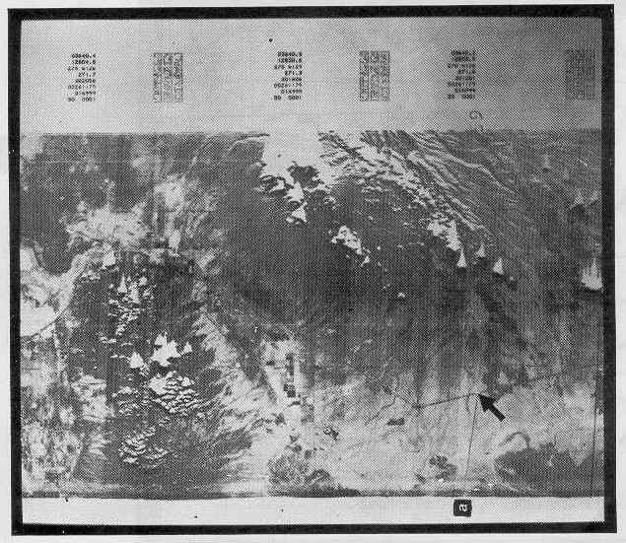

Figure 2-11.

35 IT 0646

c. Step 3: Find a point on the photo (arrow, Figure 2-11) that you can identify on the map (Figure 2-12). Place the tip of one arm of the divider on this point of the photo and the tip of the other arm on point a.

d. Step 4: Be careful not to change the adjustment of the divider and turn the small end over to the large end. As the large end represents distances on the map (for this particular instruction only), place one arm on the map (Figure 2-12) and swing an arc. For the purpose of this lesson, the proportional divider has been temporarily replaced-with a drawing compass.

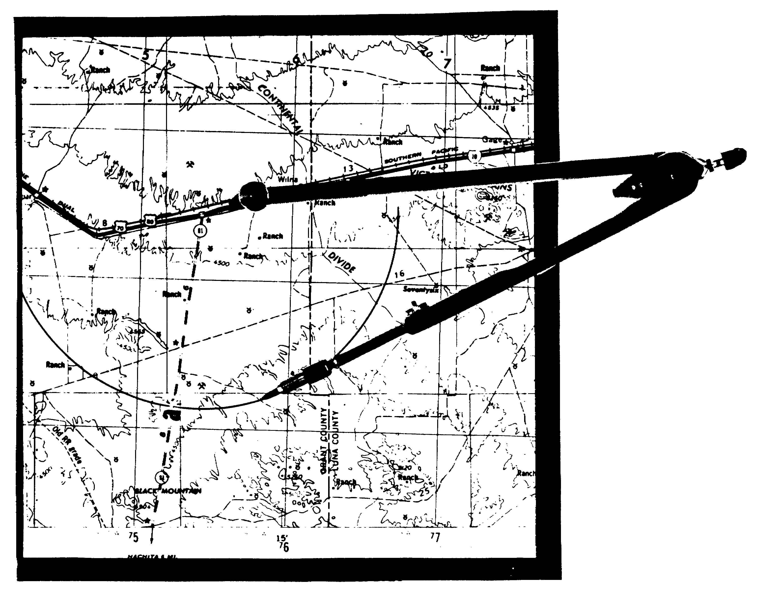

Figure 2-12.

IT 0646 36

e. Step 5: Move to another known point on the photo (arrow, Figure 2-13) and manipulate your proportional divider to fit on point "a" and the arrowhead.

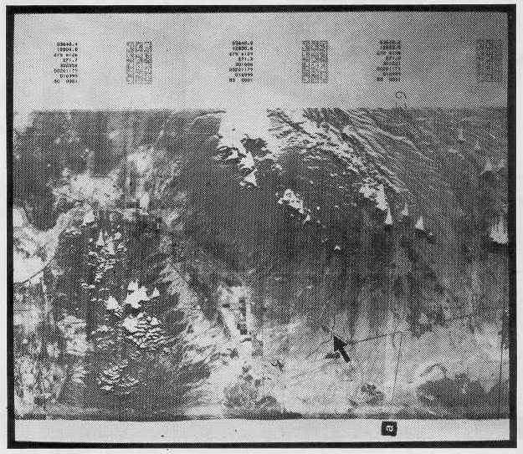

Figure 2-13.

37 IT 0646

f. Step 6: Transfer the interval to your map, adjust the proportional divider, and draw an arc from the second known point (highway junction and intermittent stream) in the general area of point "a." Where the arcs intersect, should be point "a" (Figure 2-14).

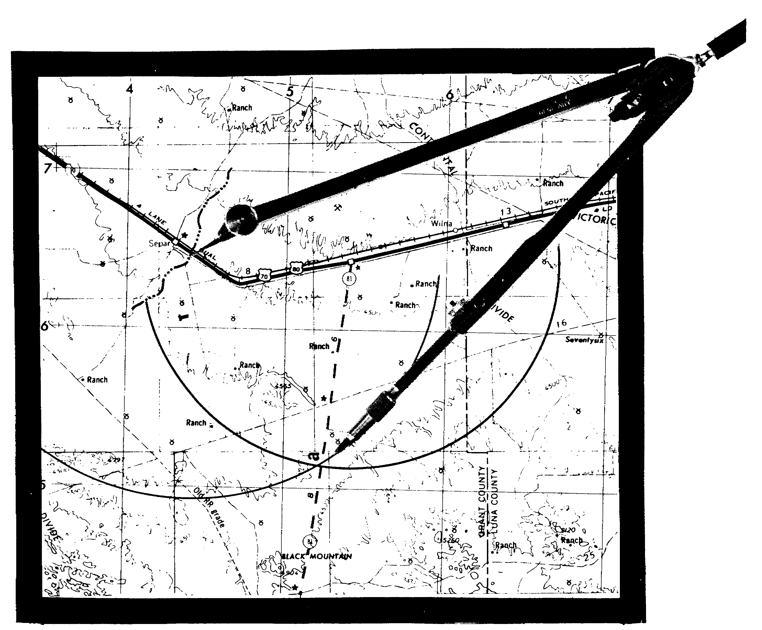

Figure 2-14.

IT 0646 38

g. Step 7: Mark additional points along the border of the frame, which is also identifiable on the map. Repeat steps 3 through 6.

h. Step 8: Draw a line through the centers of the two arc intersections, constituting one part of the plot.

i. Step 9: Select additional points recognizable along the photo frame border and map and repeat the process for all sides to complete the plot.

39 IT 0646

LESSON TWO

PRACTICE EXERCISE

The following questions will test your grasp of the material covered in this lesson. There is only one correct answer to each question. When you have completed the exercise, check your answers with the answer key that follows. If you answer any question incorrectly, study again that part of the lesson which contains the portion involved.

1. What are the easiest features to plot when using the inspection method?

A. Terrain.

B. Manmade features.

C. Relief.

D. Photo.

2. Where do the shadows generally fall in the northern hemisphere?

A. South.

B. East.

C. West.

D. North.

3. What is the TS of a 9in x 9in photo with a DPRF of 10,000 and a DMRF of 50,000?

A. 1.8in.

B. .9in x .9in.

C. 1.8in x 1.8in.

D. 2.7in x 2.7in.

IT 0646 40

4. What is the proportional divider index line setting when the distance between two points on the photo is 45mm and the distance between the same two points on the map is 15mm?

A. 2.

B. 3.

C. 15.

D. 45.

5. Use the Fort Huachuca map sheet and photo 2. Photo 2 falls in the general area of coordinates WK 6294. Prepare an interpretation photo plot using one of the methods on a sheet of 8 1/2 by 11in overlay paper. Registration marks should be placed at WK 6496 and WK 6092. The mission is UNCLASSIFIED. A legend is not required for this exercise.

41 IT 0646

LESSON TWO

PRACTICE EXERCISE

ANSWER KEY AND FEEDBACK

Item Correct and Feedback

1. B. Manmade features are easiest to plot when using the inspection method (page 26, note, 3d bullet).

2. D. Shadows fall generally north in the northern hemisphere (page 22, para la).

3. C. TS of an 9in x 9in photo is 1.8in x 1.8in. Use the
formula TS = PS x DPRF = 9 x 10,000 = 1.8in
DMRF 50,000
for each side (page 27, para 4).

4. B. The proportional divider index line setting between two points on a photo of 45mm and the same two points on a map of 15 should be 3 (page 33, para 2f).

5. Your plot should coincide with the one shown in Figure 2-15 (pages 33--39).

IT 0646 42

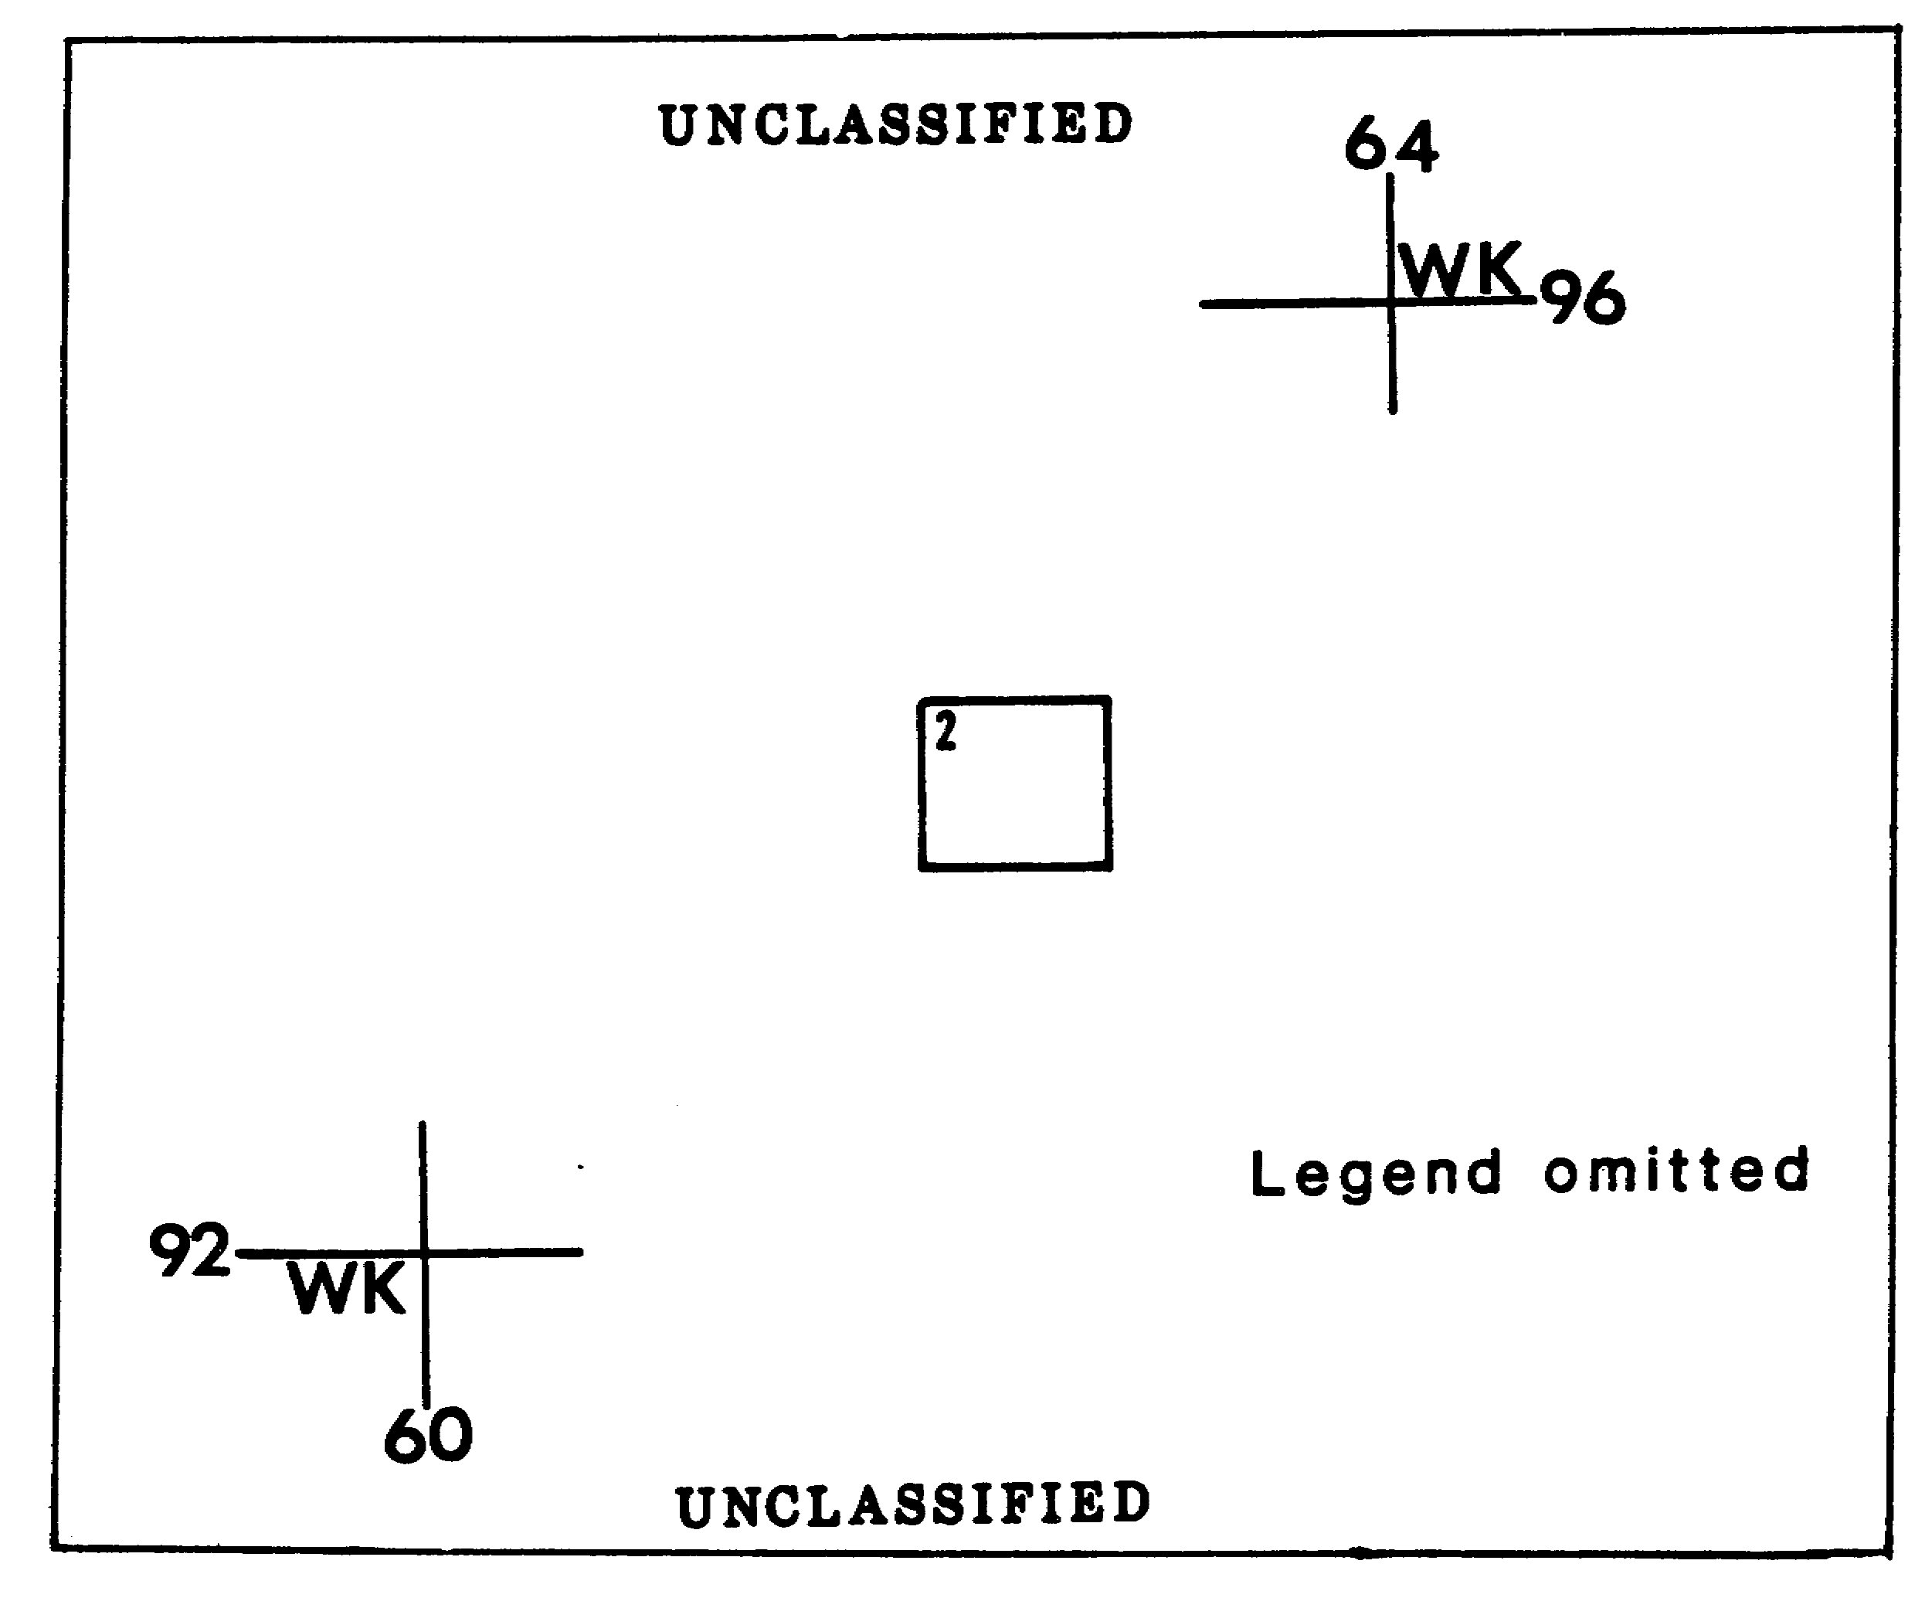

Figure 2-15.

43 IT 0646

LESSON THREE

MASTER COVER TRACE PLOTTING

MOS Manual Tasks: 301-338-1609
301-338-3701

OVERVIEW

TASK DESCRIPTION:

In this lesson you will learn to prepare and maintain a master cover trace.

LEARNING OBJECTIVE;

ACTIONS: Plot and maintain a master cover trace.

CONDITIONS: You will be given access to FM 21-26, STP 34-96D1-SM, and TC 34-55.

STANDARDS: Preparation and maintenance of a master cover trace will be in accordance with FM 21-26, STP 34-96D1-SM, and TC 34-55.

REFERENCES: The material contained in this lesson was derived from the following publications;

FM 21-26
STP 34-96D1-SM
TC 34-55.

INTRODUCTION

You should use the master cover trace as a quick check of existing imagery coverage for areas of interest. While there is no formal format for a master cover trace, you should consult your unit SOP for details of preparing and maintaining it.

IT 0646 44

PART A: MASTER COVER TRACE

1. The master cover trace is especially useful for mission planning to prevent unnecessary waste or risk of aircraft and pilot or duplication of effort over the same area. The collection management officer (CMO) of the corps all-source production section (ASPS) /collection management and dissemination (CM&D) section, for example, should double-check all mission requests to ensure an area is not already covered by a previous mission. Of course, this would depend on the type of mission request. For the intelligence preparation of the battlefield (IPB) previous coverage should be adequate. For immediate requirements, especially troop and vehicle activities, prior coverage would NOT suffice.

2. The master cover trace is (Figure 3-1):

a. A quick and ready reference to all imagery available in a unit's film library

b. Usually prepared as soon as the first aerial photo mission is received but only after all interpretation, plotting, and dissemination processes are accomplished

c. An overlay, usually keyed to a 1:250,000 scale map, with the mission number and the precise area covered by each aerial R&S mission

d. A consolidated plot of all missions received by an imagery analysis section

e. An outline of an entire mission's coverage, usually prepared by connecting the outer edges of the plotted frames of a field plot or interpretation plot

f. A plot with no runs or photo numbers.

3. Plotting rules:

a. Plot all missions in black except those which overlap previous missions.

b. Draw missions overlapping previous missions in colors other than those used for the overlapping missions.

c. Print the mission number within the plot using the same color as used for the outline. The flying unit's designation may be added unless the plot gets cluttered. Use additional overlays as required.

45 IT 0646

4. Master Cover Trace Titling:

a. Print the title "MASTER COVER TRACE" in bold letters across the top center of the overlay.

b. Print map reference data immediately below the title. Give sheet name, scale, series, and number.

c. Legend appears below center of overlay and uses six column entries, to include mission number, flying unit, imagery date, image scale, national imagery interpretation rating scale (NIIRS), and remarks.

d. Print legend entries in the same colors used for the mission plot.

5. Classification. Place the classification at the top and bottom center of the overlay in larger than any other letters.

IT 0646 46

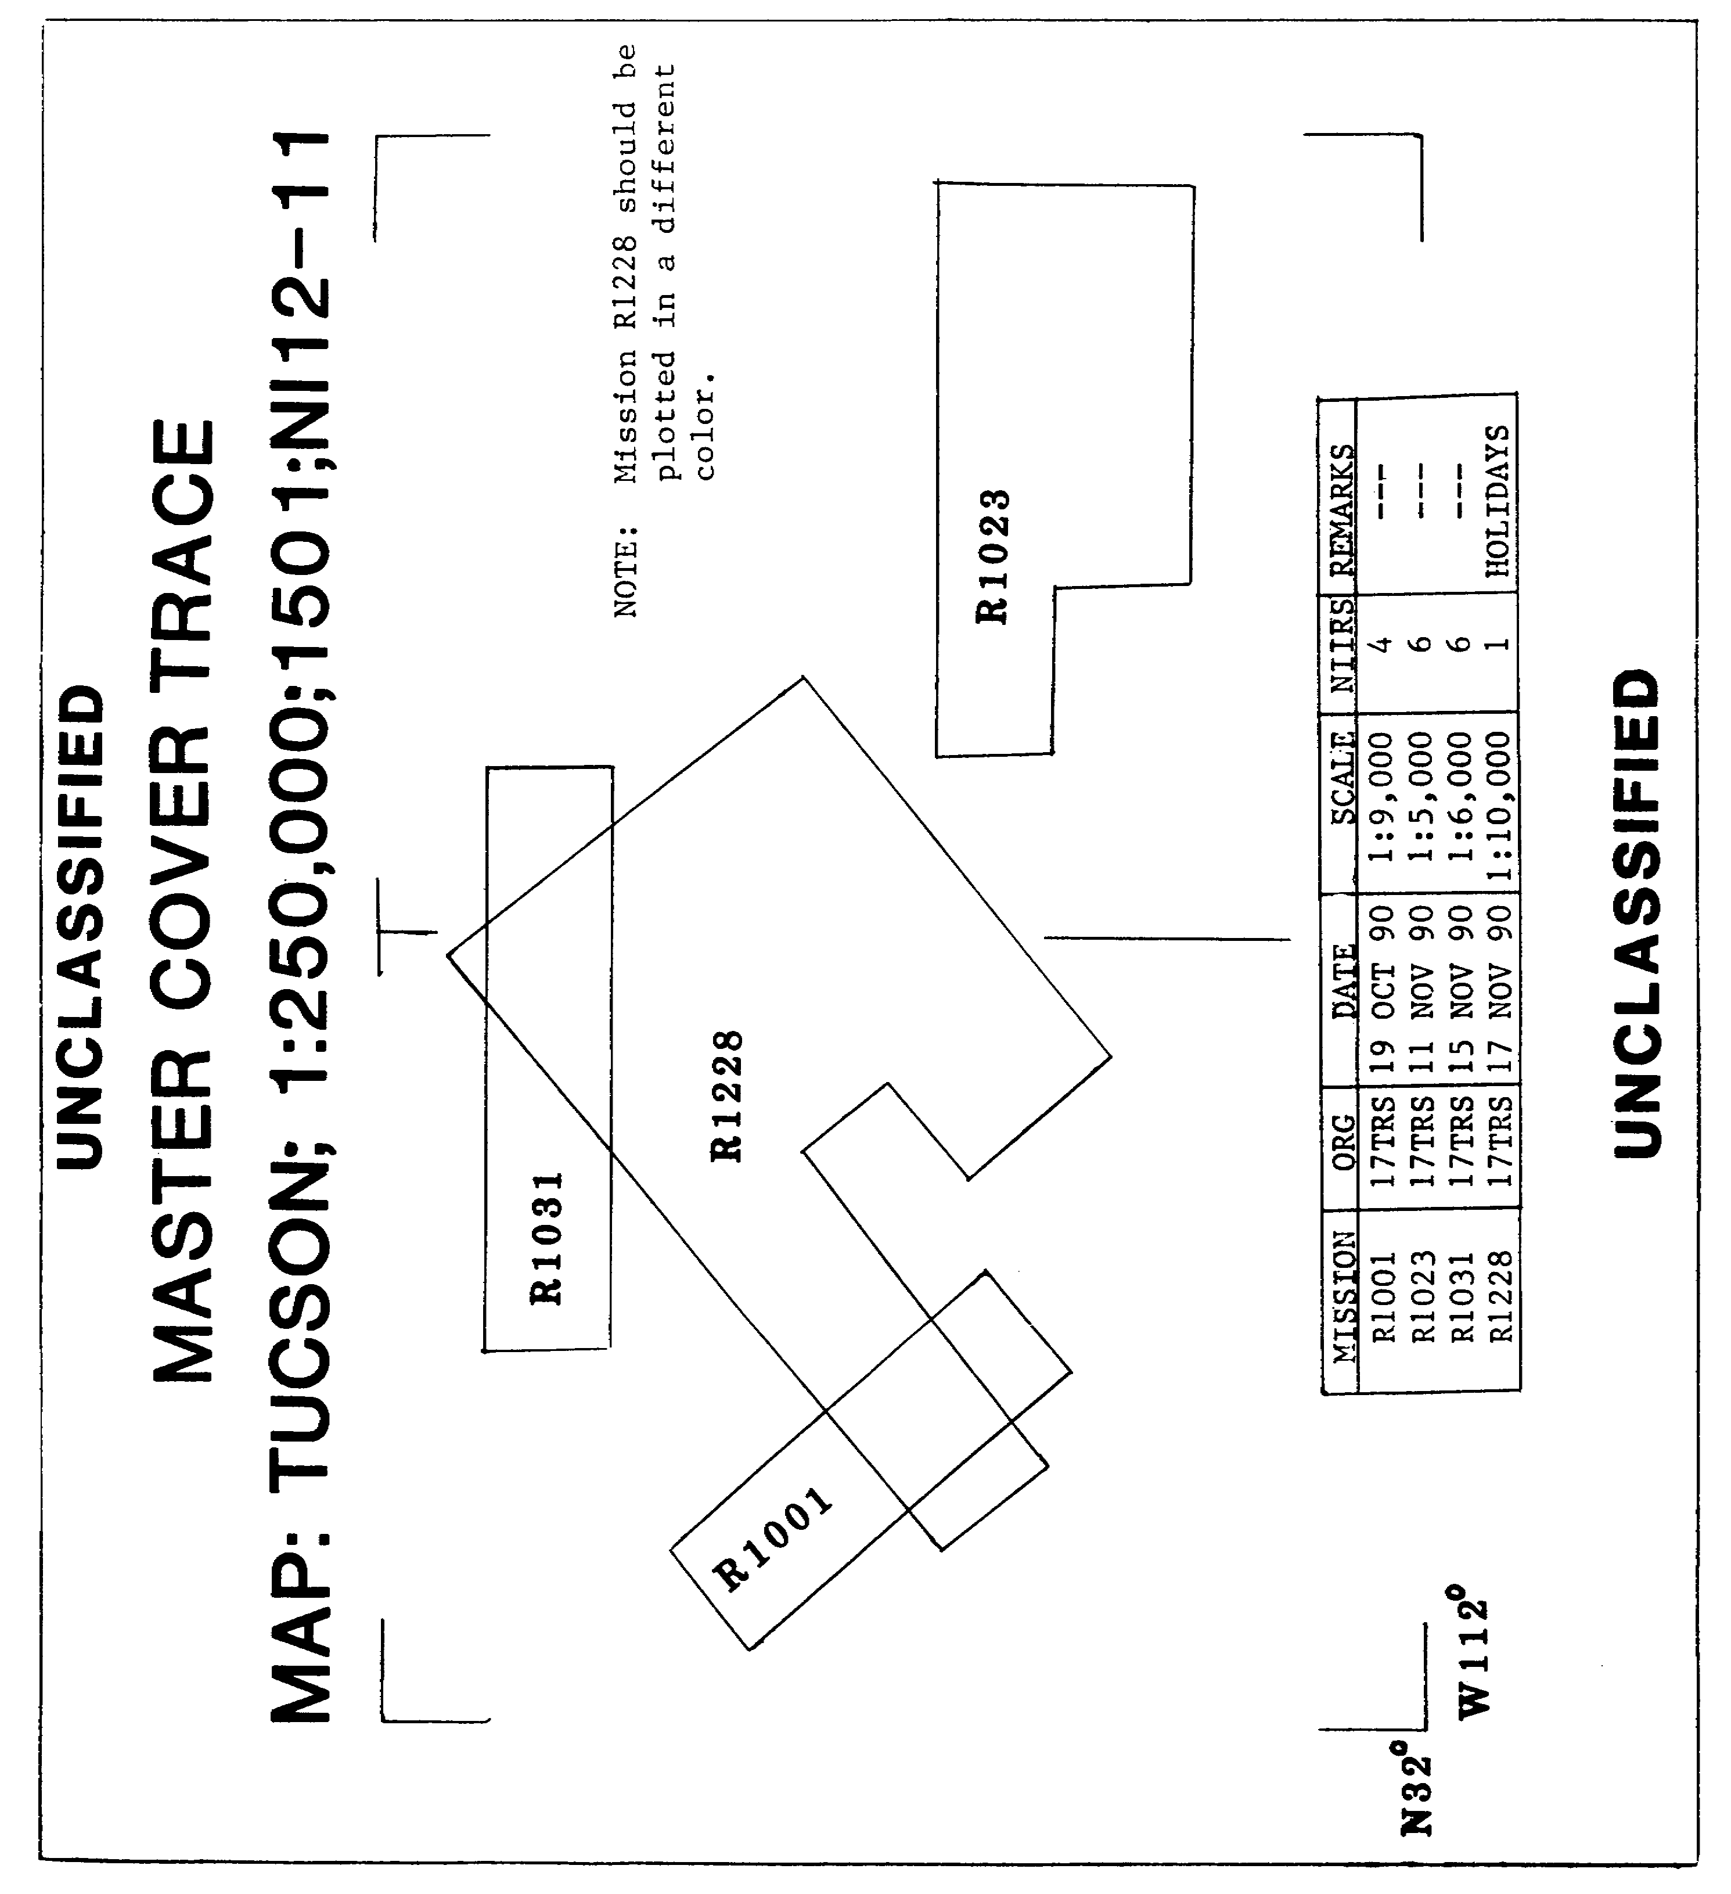

Figure 3-1. Master Cover Trace.

47 IT 0646

PART B: PREPARING AND MAINTAINING MASTER COVER TRACE

1. The master cover trace shows an outline oft an entire mission's coverage. This is normally done by outlining the field plot or interpretation plot. Plotting of the general portion of a master cover trace is accomplished In the following steps;

a. Step 1: Register the overlay to the 1:250,000 map by drawing registration marks at the top right and bottom left. Add the 100,000m grid square identification and grid square digits (Figure 3-1).

b. Step 2: Prepare the six-part legend.

c. Step 3: Enter the classification.

2. Using the field plot (which is keyed to a 1:250,000 map):

a. Step 1: Place the field plot on a map and tape it into place using the correct registration marks.

b. Step 2: Place the master cover trace over both map and field plot, using the correct registration marks.

c. Step 3: Connect the outer edges of the plotted frames by straight lines and enter the mission number.

d. Step 4: Enter the photo information In the legend. Use the same color for the legend entry as used for the plot.

3. Using the interpretation plot (which is normally prepared on a 1:50,000 map).

a. Step 1: Identify the first, last, and turn frames.

b. Step 2: Connect the outer borders of these frames with straight lines; disregard the other frames.

c. Step 3: Determine the 6-digit coordinates for each corner or angle of the plot.

d. Step 4: Transfer the coordinates from the interpretation plot based on the 1:50,000 map to the master cover trace based on the 1:250,000 map covering the same area.

(1) 1:50,000 maps show two primary digits, the 10,000 and 1,000m digits. 100m digits are obtained by using the coordinates scale (in back of the subcourse), which divides 1,000m Into 10 Increments.

IT 0646 48

(2) 1:250,000 maps show one primary digit, the 10,000m digit. The 1,000m digit is obtained using the coordinates scale. This means the grid squares represented on the 1;250,000 map contain 10 of the 1,000 meter squares, shown on the 1;50,000 map.

(3) Therefore, the second primary digit of a 1:50,000 map is obtained on a 1:250,000 map by dividing the entire grid distance by 10. For example, a reading of 90 on a 1:50,000 map would be on grid line 9 of the 1:250,000 map; to obtain 92, you must read the 2 off the coordinates scale.

49 IT 0646

LESSON THREE

PRACTICE EXERCISE

The following questions will test your grasp of the material covered in this lesson. There is only one correct answer to each question. When you have completed the exercise, check your answers with the answer key that follows. If you answer any question incorrectly, study again that part of the lesson which contains the portion involved.

1. How should you register the overlay when preparing a master cover trace?

A. Draw registration marks at the upper right and lower left of the overlay and add the 100,000m grid square identification and grid square digits.

B. Draw registration marks at the upper left and lower right of the overlay and add the 100,000m grid square identification and grid square digits.

C. Draw registration marks at the top and bottom centers of the overlay.

D. Draw registration marks on the overlay using the four corners of the map.

2. What should you add to the mission plot after it is entered on the master cover trace?

A. Classification.

B. Map sheet number.

C. Map series.

D. Mission number.

3. Which category can usually be satisfied by prior coverage?

A. Troops.

B. Vehicles.

C. IPB.

D. Artillery.

51 IT 0646

LESSON THREE

PRACTICE EXERCISE

ANSWER KEY AND FEEDBACK

Item Correct Answer and Feedback

1. A. You should draw registration marks at the upper right and lower left of the overlay and add the 100,000m grid square identification and grid square digits (page 48, para 1a).

2. D. You should add the mission number to the plot (page 45, para 3c).

3. C. A request for IPB coverage can usually De satisfied by prior cover (page 45, para 1).

IT 0646 52

